PRESS RELEASE

27th April 2022

MURASPEC INTRODUCES NEW ELIXIR

Muraspec Wallcoverings launches its most decadent luxe wallcovering design, ELIXIR.

Created by hand using artisan techniques, the fine-grained paulownia wood is cut and spliced to form this beautiful tactile, interlocking geometric pattern. The natural burls and ripple characteristics of authentic wood along with slender shiny lines of gold leaf burnished along the edges of the pattern elevate this unique design. The naturalness of the wood evokes a comforting feeling of connection to nature whilst the inlaid geometric pattern offers a ‘trompe l’oeil’ effect creating a sense of depth.

Managing Director, Tariq Rashid commented “ELIXIR is a fabulous addition to our luxe wallcovering range.
“Its pure design with the warmth of the wood marries beautifully with the gold burnish accents. This design is alluring and irresistible to the touch.
“As a contract grade product, we envisage ELIXIR to be a popular choice for interior schemes that need that wow factor.”

ELIXIR is available in cream, black, taupe, and green.

See all four eye-catching colourways in Muraspec’s ELXIR E-Book and succumb to its charm:

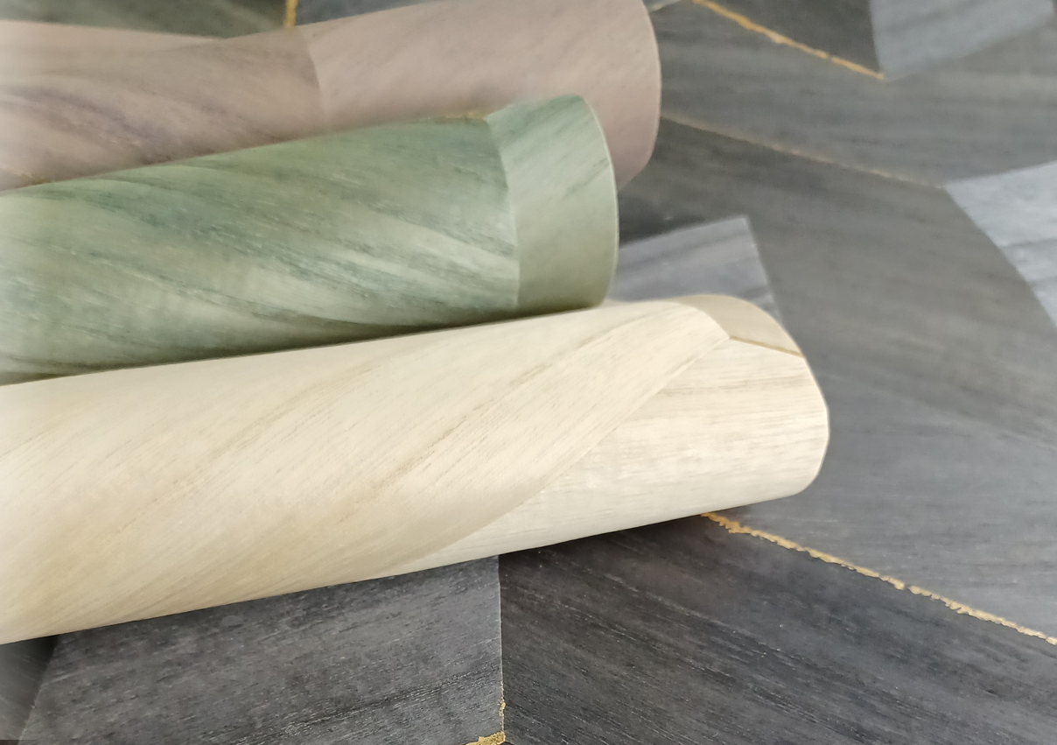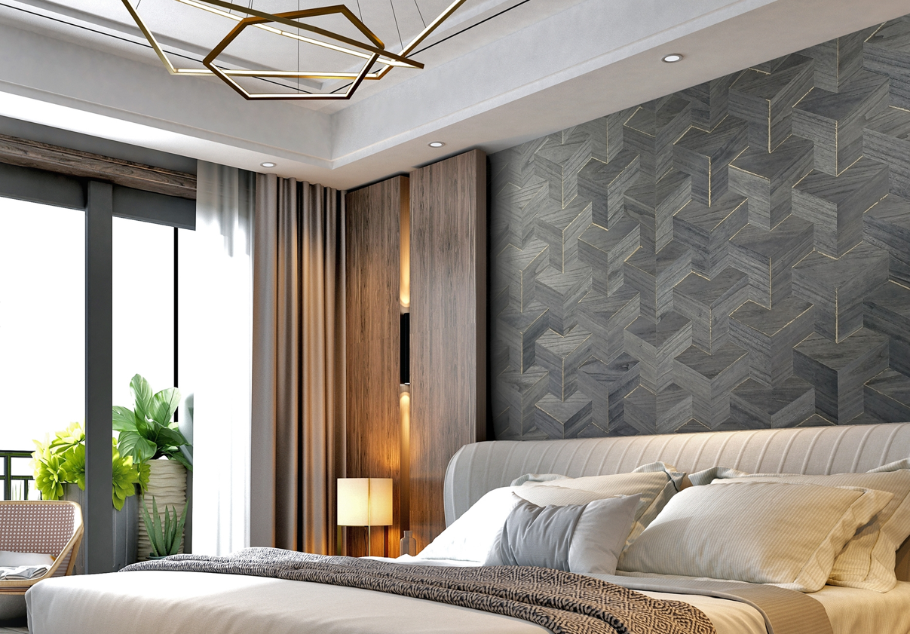

ELIXIR by Muraspec

Muraspec Wallcoverings is an international leader in the commercial and bespoke wallcoverings industry.

This year we celebrate 170 years of British manufacturing excellence. We have developed a global reputation for outstanding product quality, impressive design, and exceptional production and technical support.

From our UK sales team to our dedicated global network of distribution partners, we are proud to supply a worldwide client base across the hospitality, healthcare, commercial office, retail, cruise ship and residential sectors.

Our manufacturing facility, based in Kent, UK, manufactures a wide selection of inspiring designs using our extensive range of versatile equipment, producing high quality, fire rated wallcoverings.

Our team of experienced Technical Advisors and Account Managers are always on hand, working closely to provide a comprehensive solution from inception to completion and beyond. Our customer service is second to none. As a manufacturer, we can provide flexibility on production and are proud to have the shortest lead times in the industry.

For more information, please contact us at:

Muraspec UK
03705 117 118
customerservices@muraspec.com
www.muraspec.com

- ends –

For further press information or images, please contact:

Michelle Martin
Product Marketing Manager
Muraspec Wallcoverings
Zodiac 2, Boundary Way
Hemel Hempstead
Herts., HP2 7SJ
Tel: +44 (0)1442 883164
Mob: +44 (0)7774 898947
Email: mmartin@muraspec.com
Visit: www.muraspec.com

