PRESS RELEASE
Kogei and design inspired by white magnolia: the essence of light that fuses craft tradition and modernism
Mokuren by Naoto Fukasawa for Lladró

- The brand’s new collections, which include this innovative lighting fixture, arrive in Paris for Maison et Objet, coinciding with the brand’s 70th anniversary.

Paris, January 19, 2023.- Mokuren is the end result of the first collaboration between Lladró and the Japanese designer Naoto Fukasawa, whose work is known for its signature combination of craft and design. Tradition and modernity go hand in hand in this new chandelier, just as the purity of the metal lines are seamlessly fused with the delicacy of handcrafted porcelain flowers.

LIGHTING WITH SOUL
Lladró continues exploring different paths in its various product categories: from iconic creations that speak to the brand’s legacy and capture the sensibility inherent to the art of porcelain, to functional designs in a contemporary style that evince the brand’s mission to carry on revolutionizing the world of handcrafted porcelain.
Especially worth highlighting among its many lighting creations for this new season is the Mokuren chandelier, the end result of a collaboration between Lladró and the Japanese designer Naoto Fukasawa, who has always worked in the area straddling craft and design. For this particular work he took his inspiration from the striking beauty of the flowers of the white magnolia, one of the best-loved trees in Japan and a symbol of eternal bonds.
“When I saw the flower and thought of white porcelain, its texture and qualities, the idea came to me immediately,” Fukasawa claims. And this is how Mokuren came into being, a chandelier that couples signature elements of the work of the Japanese artist and of Lladró: nature, craft and design.
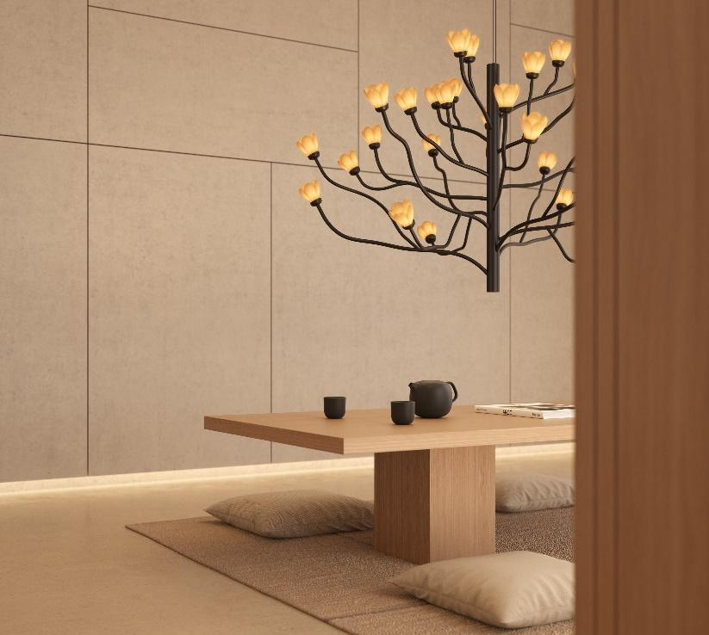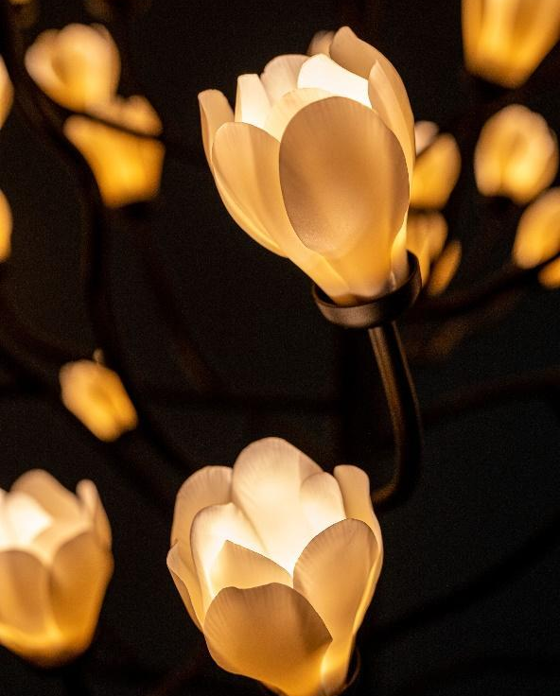

The flowers of the magnolia are attributed with meanings like nobility, while their slender exotic forms are believed to be among the most beautiful in nature. All the flowers in the Mokuren chandelier are handcrafted by Lladró’s expert artisans at its workshops in Valencia. The warm glow of LED light filtered through the translucent porcelain of the petals creates an enveloping light which can be regulated in intensity. In contrast, the black-lacquered aluminum structure, at once complex and poetic, represents the branches of the magnolia, one of the Earth’s oldest flowering plants, which has existed for over a hundred million years.
“When you see a magnolia tree in flower, you get the impression that something powerful has suddenly taken place in the natural world,” the designer explains. Fukasawa, for whom the purity of Lladró porcelain and the white of the magnolia flower seem to be connected almost naturally, has tried to capture in Mokuren the ephemeral phenomenon of the tree’s flowering and its unique ability to surprise. “The light of Mokuren accentuates its serene existence when lit. It is a pleasant soothing surprise.”

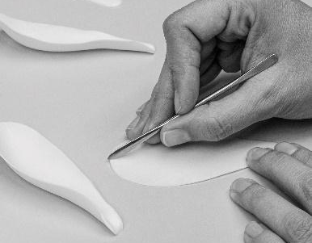
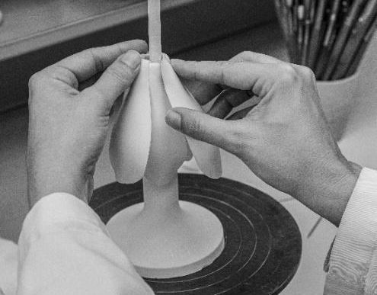
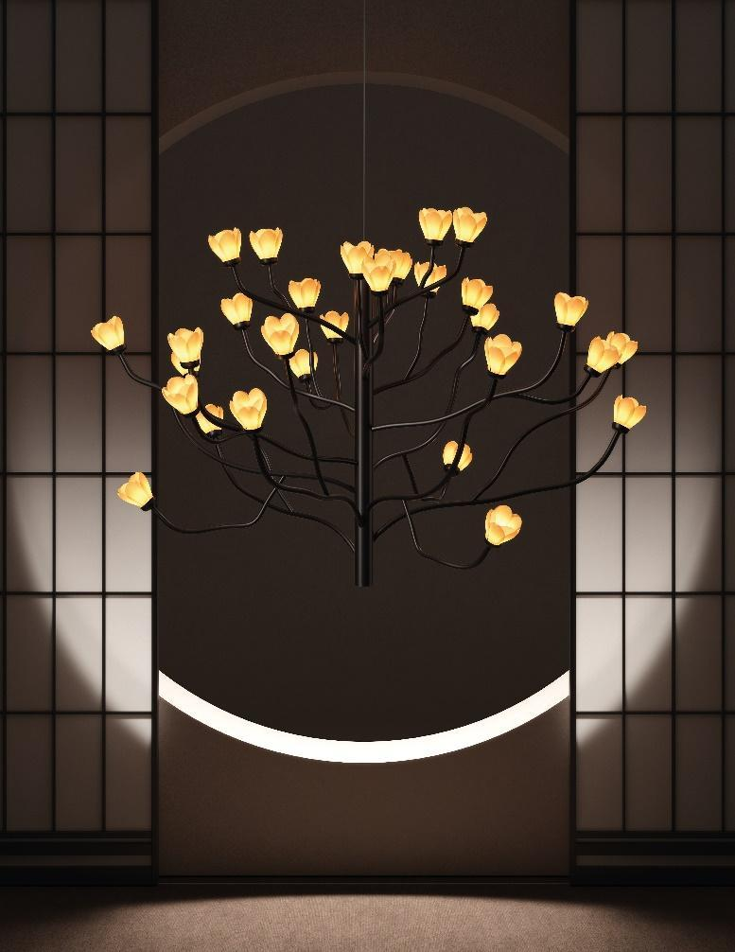

“I have the feeling that I wish to remain on the kogei (craft) side of things. But when it comes to lighting, it has to be interpreted from the viewpoint of design. Mokuren is a triumph of both. It was the perfect mix.”
Naoto Fukasawa

NAOTO FUKASAWA
Naoto Fukasawa was born in the prefecture of Yamanashi in Japan. After graduating from Tama Art University, one of Japan’s most prestigious art schools, he developed his professional career as a product designer for major American, European and Japanese companies.
His style is characterized by a combination of functionality and minimalism, industrial production and kogei (crafts). For Fukasawa designing means observing objectively, analyzing the relationship between the object and its surroundings (tatazumai), its use and the space it occupies.
Passionate about kogei, Fukasawa believes that the value of a handmade object is increased when it is approached through the lens of design. And so, he loves to explore the boundary where craft and design overlap and indeed he claims that the line between them must often be completely erased in order to create the best objects possible.
Fukasawa has received many prizes, was given the honorary title of Royal Designer for Industry by the Royal Society of Arts in the UK, and was presented with the 2018 Isamu Noguchi Award. He is a professor at Tama Art University and, since 2012, is also the director of the Japanese Folk Crafts Museum in Tokyo.

LLADRÓ AT MAISON&OBJET 2023
From January 19 through 23 in Maison&Objet, one of the world’s major events for the design and decor industry, Lladró is revealing the collections that will capture the attention this coming spring–summer season. The event also coincides with the beginning of a very special and meaningful year for Lladró, because in 2023 it is commemorating its first seven decades revolutionizing the world of porcelain.
The brand will be unveiling new collections conceived as a celebration of beauty and imagination, born from constant experimentation, the search for new forms, new colors and textures and new sources of inspiration. Also on view, apart from the Mokuren chandelier, are creations from varied collections of contemporary sculptures inspired by the animal kingdom, some of the highpoints of the Lladró New Concept catalogue, as well as much-awaited figurines paying tribute to such lovable characters as Grogu and Snoopy.
All the pieces presented at Maison&Objet 2023 are designed and painstakingly handcrafted by Lladró artists in Valencia and can be purchased from the Spring-Summer 2023 season in Lladró boutiques, in authorized points of sale and in the online store www.lladro.com.

LLADRÓ LIGHTING, WARMTH AND DECORATIVE STRENGTH WITH AN ORGANIC INSPIRATION
Lladró’s lighting collections combine elements of light and the earth to achieve a delicate balance between creativity and artistic innovation and craft technique. Chandeliers as well as tabletop, wall and standing lamps whose impact goes way beyond their lighting function. Customizable and enveloping lighting that makes the most of the exceptional qualities of porcelain.

Lladró, 21st-century porcelain
For seventy years, Lladró has deployed its unparalleled know-how in the field of porcelain in its only factory in the world, in Valencia. Each piece is delicately made by sculptors and artisans in an entirely handcrafted process that combines age-old techniques with its own unmistakable palette of colors. Lladró also explores the vast creative potential of porcelain in collaborative projects with renowned contemporary artist and designers. The brand’s universe embraces sculptures, lighting, objects for the home and interior design as well as fashion accessories. Famous all over the world, Lladró is an ambassador for Spain in the over 120 countries to which it exports its porcelains through a select network of its own boutiques and distributors.

For more information:
Alicia González
IT COMUNICACIÓN
Anna Castro / Marta Jacob
Tel.: +34 93 362 10 34
E-mail: acastro@itcomunicacion.com / mjacob@itcomunicacion.com
Head of Communication
Tel.: +34 96 318 70 00 - Ext.: 2005
agonzalez@es.lladro.com
www.lladro.com

