M42 junction 6 Bickenhill restriction
The NEC remains fully open and accessible, and inbound routes are operating as normal.
National Highways has identified deterioration to the bridge on the northern side of the M42 Junction 6 roundabout. The bridge is due to be demolished, with temporary traffic restrictions and diversions expected to remain in place over the coming months.
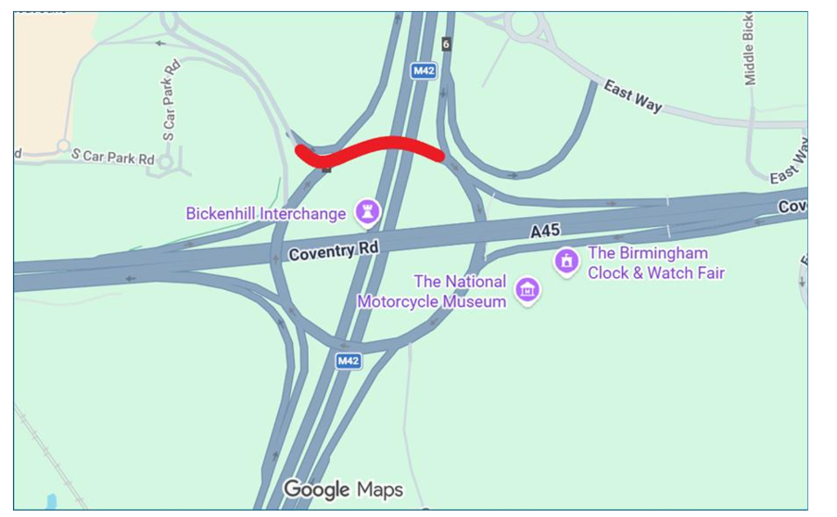M42 J6 Bickenhill bridge closure location
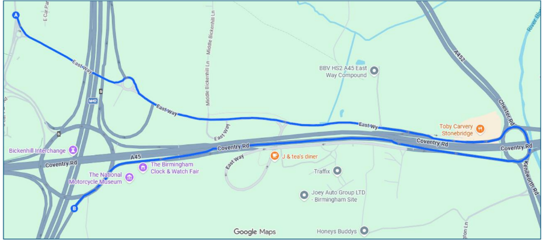Directions from NEC (East Way) to M42 Southbound
From the NEC (top left on map), travel along East Way to Stonebridge Island.
Take the 4th exit along A45W (Coventry Road) toward Birmingham airport. Exit at the next junction to join the M42 Southbound, Junction 6.
