BEVERAGE ORDER & DIETARY REQUEST FORM

Event: Broadcast awards 2026 | 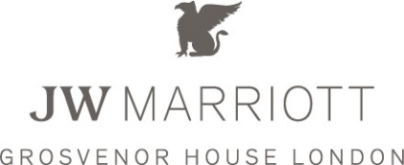
Date: 4th February 2026
Company Name:
Address: Telephone Number:
E-mail:
Contact person:
Host Name: Title:
Number of Tables: Numbers Attending: Table Number/s (if known):

WINES & CHAMPAGNES OTHER BEVERAGES (quantity per table)
Bin No  (4 digit code) | Quantity Per Table | Price Per Bottle

Sparkling Mineral Water
Still Mineral Water

DIETARY REQUIREMENTS:

Name of Guest | Table number (if known) | Special Dietary Requirement -Vegetarian, Allergies, etc…

PLEASE RETURN THE FORM AT LEAST 48 HOURS BEFORE THE EVENT TO BELOW EMAIL:
grosvenor-house.private.hospitality@marriott.com

Beverages can also be ordered at the table with your allocated wine waiter however please note that a slight delay may be experienced when ordering or arrival at the table.

PAYMENTS:

All payments are requested at the event on the table, either by cash or credit/debit card.
N.B. A discretionary 12.5% service charge will be added to all beverages.

Should you wish to pre-pay by credit/debit card, please send us a request via email us to obtain a SECURE ONLINE PAYMENT LINK
You may also make an advance payment by BACS or CHAPS (please contact us for further details), ensuring all funds are received before the event.

Contact details: grosvenor-house.private.hospitality@marriott.com; Tel: 0207 399 8449

JW Marriott Grosvenor House London
86-90 Park Lane, London, W1K 7TN United Kingdom

