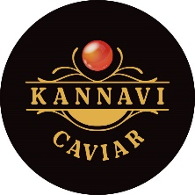
Premium Red Roe from Kannavi Caviar
Kannavi Caviar introduces a premium selection of red roe to the UK market.
Kannavi Caviar specialises in high-quality fish roe sourced from trusted producers and handled
under strict cold-chain logistics to ensure optimal freshness, flavour and quality.
Our portfolio includes:
- Chum (Keta) Salmon Roe ( Alaska)
- Pink (Gorbuscha) Salmon Roe (Alaska)
-Trout Roe (Denmark)
These premium products are carefully selected to deliver consistent quality, vibrant colour and a refined taste profile suitable for retail, wholesale and foodservice sectors.
All Kannavi Caviar products are 100% natural and contain no preservatives, meeting the
growing demand for authentic and clean-label seafood products.
With a focus on premium quality and reliable supply, Kannavi Caviar is currently looking to connect
with UK distributors, wholesalers, speciality food retailers and foodservice partners
interested in expanding their seafood offering with high-quality red roe.
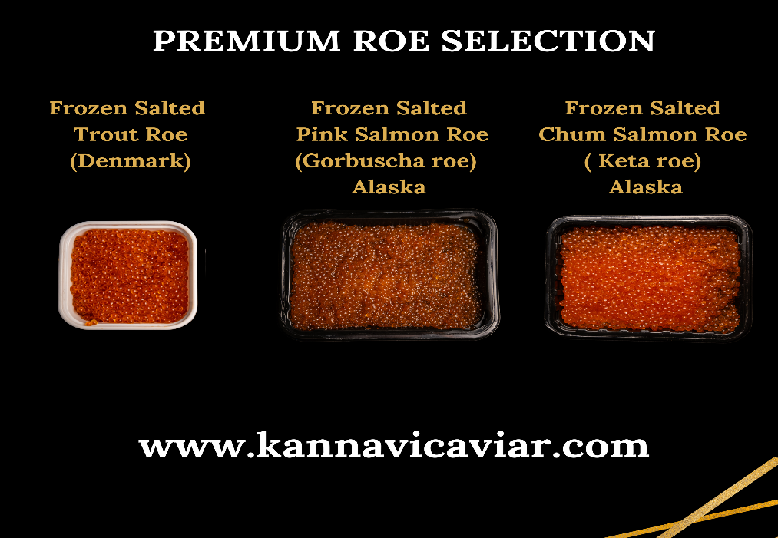

Contact Us:
+447881685294
info.kannavi@gmail.com
Website: www.kannavicaviar.com
Instagram: @best_caviar_london

