ALLERGEN INFORMATION SHEET – Food Allergen Content [INSERT THE NAME OF YOUR FOOD BUSINESS HERE]

FOODS | 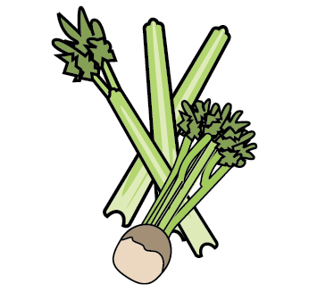 | 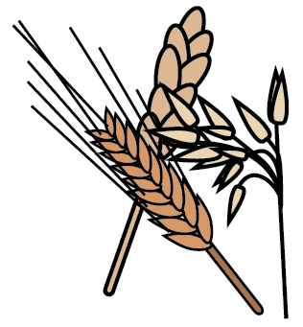 | 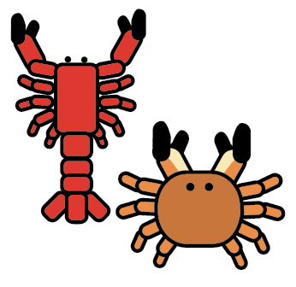 | 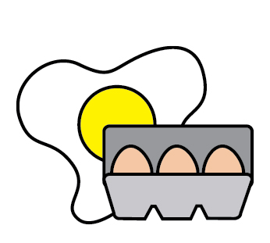 |  | 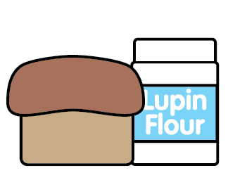 | 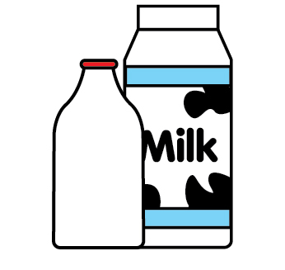 |  | 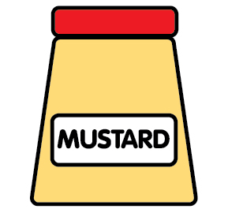 | 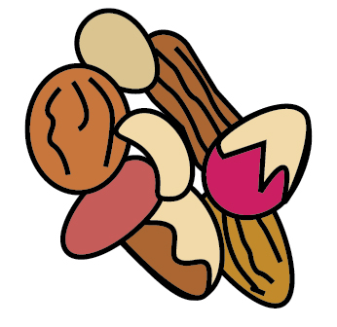 | 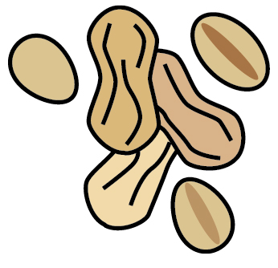 | 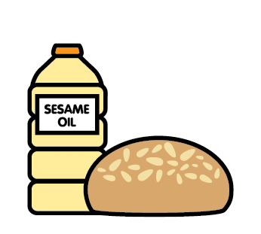 |  | 
List and tick as appropriate | Celery | Cereals containing gluten | Crustaceans | Eggs | Fish | Lupin | Milk | Mollusc | Mustard | Nuts | Peanuts | Sesame seeds | Soya | Sulphur Dioxide
Tuna Salad [example] | ✓ |  |  | ✓ | ✓ |  | ✓ |  | ✓
- Sample tick can be copied and pasted into chart where applicable. Please delete this line when the chart is completed.

Review date: |  | Reviewed by: |  |  | You can find this template, including more information at www.food.gov.uk/allergy

