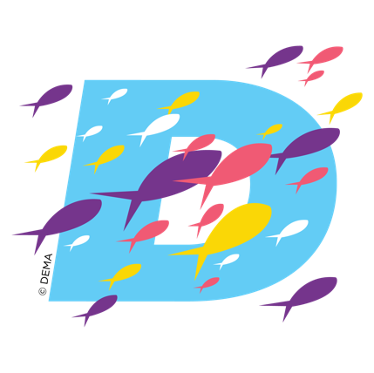
DEMA SHOW 2024
Event Overview

DEMA Show is the Diving Equipment & Marketing Association’s (DEMA) annual trade-only event and is the premier gathering of diving, travel, and action water sports professionals. Held annually, DEMA Show unites thousands of industry stakeholders, including manufacturers, suppliers, retailers, dive operators, instructors, and more, from around the globe. This expansive event offers a comprehensive showcase of the latest innovations, technologies, products, and services in the diving industry.



EVENT DETAILS

DEMA Show 2024: November 19—22, 2024
Location: Las Vegas Convention Center, Las Vegas, Nevada

KEY FEATURES AND ASPECTS OF DEMA Show

1. Exhibit Hall: At DEMA Show, attendees have the opportunity to explore a vast exhibition floor featuring 600+ exhibitors presenting a wide range of diving equipment, gear, accessories, apparel, travel destinations, and more. From cutting-edge diving gear to eco-friendly products and conservation initiatives, the exhibit hall offers something for everyone.

2. Education Sessions: In addition to the exhibit hall, DEMA Show hosts 250+ educational sessions, workshops, seminars, and training programs led by industry experts. Sessions cover diverse topics such as dive safety, environmental conservation, business management, marketing strategies, industry trends, and more, enabling attendees to enhance their knowledge, skills, and expertise.
3. Networking Opportunities: One of the key highlights of DEMA Show is the networking opportunities it provides. Attendees can connect with industry professionals, establish valuable contacts, forge partnerships, and exchange ideas and experiences. Whether it's networking events, social gatherings, or business meetings, DEMA Show offers numerous avenues for building relationships within the diving community.

4. Advocacy, Collaboration, and Innovation: DEMA Show is not only a platform for business development and networking but also a hub for advocacy, collaboration, and innovation within the diving industry. It serves as a catalyst for growth, sustainability, and excellence in diving practices worldwide.

5. Dynamic Experience: Overall, DEMA Show offers a dynamic and immersive experience for diving professionals, enthusiasts, and industry stakeholders, providing invaluable insights, opportunities, and resources to advance the diving industry and promote the enjoyment and preservation of our underwater world.

For the most up-to-date information about DEMA Show 2024, including the schedule of events, location information, and specific features, visit www.demashow.com.

