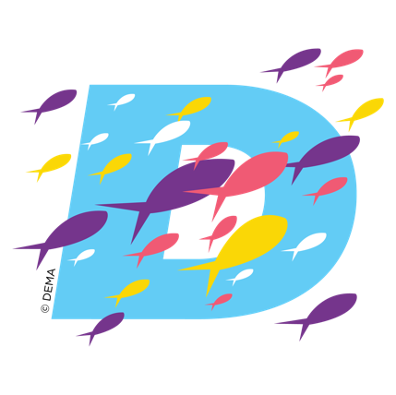
DEMA SHOW 2024
Justification Points

Below are key points to consider when justifying attendance at DEMA Show 2024, the premier event for professionals in the diving, travel, and action water sports industry:

- Industry Networking: DEMA Show offers unparalleled opportunities to network with professionals across the diving sector, including manufacturers, suppliers, instructors, dive operators, and industry experts. With thousands of attendees from around the world, the potential for forging valuable connections and collaborations is immense.
- Access to the Latest Innovations: The exhibit hall at DEMA Show showcases the newest technologies, equipment, and services in the diving industry. Attending allows organizations to stay at the forefront of industry trends, explore cutting-edge innovations, and discover new solutions to enhance dive operations and services.
- Educational Insights: DEMA Show features a comprehensive lineup of educational sessions, workshops, and presentations led by experts in the field. These sessions cover a wide range of topics, including dive safety, environmental conservation, equipment maintenance, industry regulations, and more, providing attendees with valuable insights and knowledge to improve dive operations.
- Product Comparisons: DEMA Show offers a unique opportunity to directly compare different products and services from a diverse array of exhibitors. This enables organizations to make informed decisions about investments in equipment, gear, and technologies that can enhance safety, efficiency, and customer satisfaction.
- Policy and Advocacy Engagement: DEMA Show provides a platform for discussions on policy initiatives, regulatory updates, and advocacy efforts relevant to the diving industry. Attendees can engage to address key issues and promote policies that support the growth and sustainability of diving activities.
- Professional Development: DEMA Show offers a range of professional development opportunities, including certification courses, workshops, and seminars, designed to enhance attendees' skills and expertise in various aspects of diving operations, instruction, and business management.
- Awareness of Industry Challenges: By participating in DEMA Show, attendees gain a deeper understanding of the challenges and opportunities facing the industry, including environmental conservation, safety standards, and business sustainability. This knowledge can inform strategic decision-making and help organizations navigate complex industry dynamics.
- Benchmarking and Best Practices: DEMA Show provides a platform for sharing best practices, lessons learned, and success stories among professionals. By benchmarking against peers and learning from industry leaders, organizations can identify opportunities for improvement and optimize their business operations and customer experiences.
- Exposure to Sustainable Practices: DEMA Show often highlights sustainable diving practices, eco-friendly products, and conservation initiatives aimed at reducing the environmental impact of diving activities. Attendees can gain insights into adopting greener practices and promoting environmental stewardship within their organizations and the broader diving community.
The benefits of attending DEMA Show 2024 extend beyond these points and may vary based on individual roles, organizational goals, and industry trends. It's essential to customize your justification based on your specific needs and objectives to maximize the value of your participation in this premier industry event.

Benefits/Sample Statements

Key Benefits to Your Organization | Sample Statements of How DEMA Show Provides Key Benefits
Networking | Attending DEMA Show 2024 will allow me [names of team members] to connect with fellow diving industry professionals and vendors. Through interactions at the event, I [we] can exchange insights, share experiences, and establish valuable contacts, fostering collaboration and potential partnerships that can drive business growth and professional development.
Industry Insights | DEMA Show serves as a comprehensive platform where I [we] can gain in-depth industry insights, stay abreast of the latest trends, and learn about cutting-edge technologies and innovations shaping the diving, travel, and water sports industry. By attending seminars, workshops, and product demonstrations, I [we] can enhance my [our] knowledge base, identify emerging opportunities, and gain a competitive edge in the market.
Product Showcase | Attending DEMA Show will allow me [us] to explore an extensive exhibition showcasing a diverse range of products, equipment, and services from leading manufacturers and suppliers in the diving, travel, and water sports industry. I [we] look forward to evaluating new product launches, exploring equipment demos, and comparing offerings from different vendors, enabling me [us] to make informed purchasing decisions and potentially establish partnerships with suppliers that best meet our business needs.
Professional Development | Participating in educational sessions, workshops, and certification programs offered at DEMA Show will empower me [us] to enhance my [our] skills, expand my [our] expertise, and stay updated on industry best practices and regulatory requirements. By investing in professional development opportunities at the event, I [we] can advance my [our] career[s], increase job satisfaction, and contribute more effectively to the organization.
Business Expansion | DEMA Show serves as a strategic platform for me [us] to expand our business networks, explore new markets, and identify potential clients, distributors, and collaborators. Whether we're seeking to enter new geographic regions, diversify our product offerings, or forge strategic alliances, I [we] can leverage the diverse ecosystem of stakeholders present at the event to explore growth opportunities and expand our business horizons.
Market Intelligence | Attending DEMA Show will enable me [us] to gather valuable market intelligence, including competitive analysis, consumer trends, and industry benchmarks. By engaging with industry experts, attending market briefings, and accessing research reports and data analytics, I [we] can gain actionable insights that inform our strategic decision-making, product development, and marketing strategies, thereby enhancing our competitive positioning and profitability.
Community Engagement | DEMA Show fosters a sense of community and camaraderie among attendees, providing a platform for professionals from diverse backgrounds to come together, celebrate our shared passion for diving, and exchange ideas and experiences. Through participation in networking events, social gatherings, and community initiatives, I [we] can build lasting relationships, mentorship opportunities, and a support network that enriches both my [our] personal and professional life [lives].
Sustainability Initiatives | Attending DEMA Show will give me [us] the opportunity to learn about the latest advancements and initiatives in sustainable practices, environmental conservation, and responsible tourism within the diving industry. I'm [we’re] excited to explore eco-friendly products, conservation efforts, and corporate social responsibility initiatives undertaken by exhibitors and industry leaders, inspiring me [us] to advocate for and adopt more sustainable business practices that align with our company values and contribute to the preservation of marine ecosystems for future generations.

