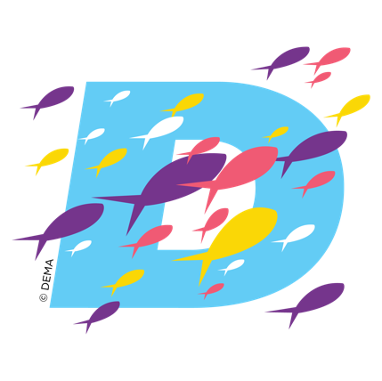
DEMA SHOW 2024
Top Reasons to Attend

Attending DEMA Show offers numerous benefits and opportunities for professionals in the diving, travel, and action water sports industry, including but not limited to:

- Networking: DEMA Show provides unparalleled networking opportunities with industry professionals, manufacturers, suppliers, and experts in the industry, fostering collaborations and partnerships.
- Access to the Latest Innovations: Attendees can explore the latest advancements in diving equipment, technologies, and services showcased by leading manufacturers and suppliers, staying ahead of industry trends.
- Educational Insights: DEMA Show features hundreds of diverse education sessions, workshops, and presentations led by experts in their fields, covering a wide range of topics including dive safety, marketing best practices, business management, and more.
- Product Comparisons: Attendees can directly compare different products and services from various exhibitors, enabling informed decision-making on purchases and investments.
- Professional Development: Participation in DEMA Show offers opportunities for professional growth and skill development through workshops, certification courses, and industry-specific training sessions.
- Business Expansion: DEMA Show is a strategic platform for expanding business networks, exploring new markets, and identifying potential clients, distributors, and collaborators.
- Industry Insights: By attending DEMA Show, participants gain insights into emerging trends, challenges, and opportunities in the industry, informing strategic decision-making and business planning.
- Sustainability Initiatives: DEMA Show highlights sustainable diving practices, eco-friendly products, and conservation efforts, providing attendees with insights into adopting greener solutions and reducing environmental impact.
- Collaboration and Partnership Building: DEMA Show facilitates collaboration and partnership building among diving professionals, organizations, and stakeholders, fostering innovation and growth within the industry.
- Exposure to Global Market Trends: Attendees gain exposure to global market trends, regulatory developments, and best practices, sharpening their competitive edge and enhancing their positioning within the diving industry.

The benefits of attending DEMA Show can vary based on individual goals and interests. Whether you're looking to learn, shop, network, explore innovations, or stay updated on industry trends, this event offers a comprehensive platform to achieve your goals.

