Vegas LOOP at Las Vegas Convention Center

The Las Vegas Convention Center also offers fast, convenient, free on-campus transportation!

Looking to travel around the Las Vegas Convention Center campus? Vegas LOOP at the Las Vegas Convention Center quickly transports passengers throughout the 200-acre Las Vegas Convention Center campus in a fun and convenient way, free of charge. The system consists of two one-way, .8-mile-long tunnels built to accommodate all-electric Tesla vehicles driving at speeds of up to 35 mph. The LVCC Loop reduces a 25-minute walk to a less than two-minute ride.

Attendees can access Vegas LOOP at Las Vegas Convention Center via four stations:

- South Station – Adjacent to South Hall, this station is located aboveground
- Central Station – Near the Central Hall Main Entrance, this station is located belowground and is accessible via escalator or elevator
- West Station – Adjacent to West Hall, this station is located aboveground
- Riviera Station – At the North side of the West Hall closest to Elvis Presley Drive, with direct access to Resorts World. This station is located aboveground.

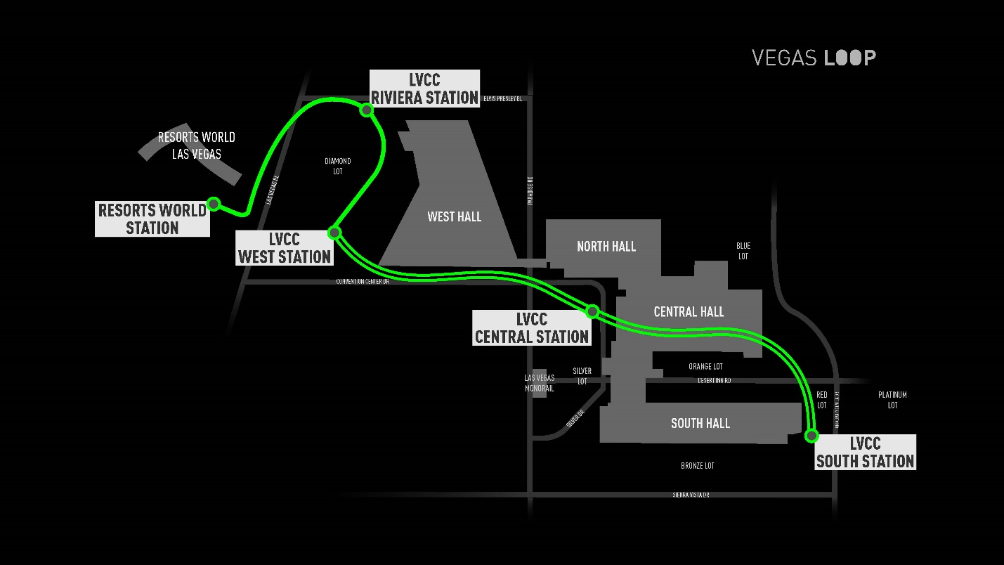

The Vegas LOOP has officially opened the Resorts World Passenger Station, providing direct access to and from the Las Vegas Convention Center. Riders can now access the Resorts World station from any of the Convention Center stations (South Station, Central station, West Station and Riviera Station).

There is currently no charge to travel between stations at the Convention Center or from The Convention Center to Resorts World Station.

Visit lvloop.com/tickets to purchase tickets for rides departing from Resorts World. Hours of operation will vary based upon event calendar at the Las Vegas Convention Center.

