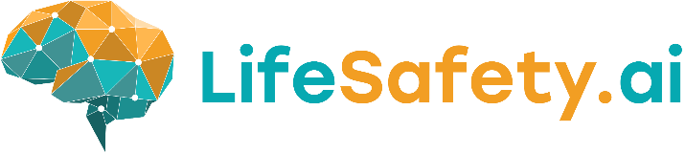

FOR IMMEDIATE RELEASE
Lifesafety.ai Unveils Revolutionary AI-Powered Health & Safety Software at The Health & Safety Event NEC Birmingham
Birmingham, UK – 23/01/2025 – Lifesafety.ai, a pioneer in innovative safety solutions, is thrilled to announce the launch of its groundbreaking AI-Powered Health & Safety Software. This cutting-edge technology is set to transform the industry, enhancing safety protocols with advanced AI capabilities. Lifesafety.ai invites industry professionals, stakeholders, and media to join them at The Health & Safety Event, taking place at NEC Birmingham from April 8-10, 2025.
The highlight of this year's showcase is Lifesafety.ai’s AI PPE Detection Software, which leverages artificial intelligence to ensure that safety gear is worn correctly in real-time, significantly reducing workplace accidents and enhancing compliance with safety regulations.
Event Details:
- What: Lifesafety.ai Software Launch and Live Demonstration
- Where: The Health & Safety Event, NEC Birmingham, Stand 3/R2
- When: April 8-10, 2025
Attendees will have the exclusive opportunity to experience firsthand the capabilities of this innovative software. Lifesafety.ai’s team will conduct live demonstrations, showcasing how the technology can seamlessly integrate into existing safety protocols and provide immediate enhancements in safety oversight and compliance.
“We are excited to bring our AI-powered solutions to the forefront of the health and safety industry,” said Mark Page, HSE Product Owner of Lifesafety.ai. “Our technology is designed not only to meet current industry standards but to set new benchmarks in safety management. We invite everyone to visit our stand 3/R2 at The Health & Safety Event to see the future of workplace safety.”
For additional information about Lifesafety.ai and to schedule a personalized demo during the event, please contact:
contact@lifesafety.ai
We look forward to seeing you at NEC Birmingham and together, advancing the standards of workplace safety.
About Lifesafety.ai
Lifesafety.ai is committed to developing innovative safety solutions that integrate cutting-edge AI technology to protect lives and prevent injuries in the workplace. Our solutions are designed to enhance the efficiency and effectiveness of health and safety protocols, ensuring a safer work environment for all.
Media Contact:
Mark Page
HSE Product Owner
www.lifesafety.ai

