Fall Arrest or Restraint?

“Elimination, Engineering Controls and PPE” make up the hierarchy of controls for working at height. In consideration, Work Restraint trumps Fall arrest every time. It is generally accepted that by restraining a person from the risk of a fall reduces the risk to the user. This is largely true however, in my opinion the potential to misunderstand the limitations of equipment by the user does increase significantly, therefore specific training and understanding is essential.
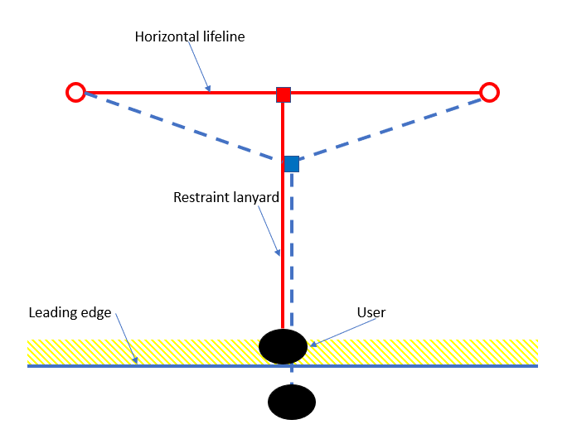
What is Restraint?
Restraint is the provision of PPE. Usually, a fixed length lanyard or webbing that physically restrains the user from a hazard, typically a leading edge. In simple terms the user is suitably restrained that regardless of position, seated or standing they cannot reach the edge.
Often a work activity is categorised as restraint when the user is still exposed to the risk of a fall.
One example of a Work Restraint (pictured), is using a flexible horizontal lifeline to provide freedom of movement parallel to the edge, allowing the user access to the edge with his hands. The problem here is, when the user stands, he can potentially position his feet over the edge creating the increased risk of a fall. This in turn will stretch/deflect the horizontal lifeline allowing for a fall on restraint equipment not designed to mitigate the impact.
Complications
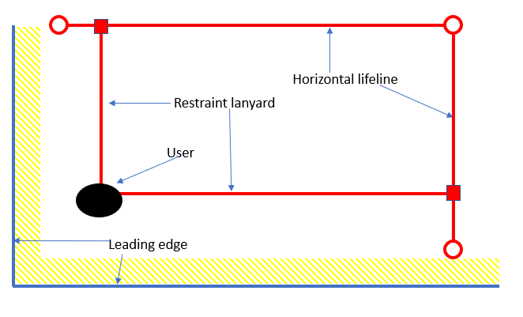
It is worth considering, that work restraint can be somewhat of a blunt tool if presented with multiple hazards or leading edges.
See example (pictured), the user is facing 2 leading edges and to maintain restraint has been given 2 horizontal lifelines and 2 adjustable restraint lanyards. Requiring continued adjustment to maintain restraint in relation to their position.
Complexity of use
Increased hazards and a greater variety of risks that present to a user, the more complex the restraint solution must become or the greater the selection of equipment they have to draw from.
As a result, it is essential that the user is competent to use the equipment, fully understand all risk, the equipment’s proper use and make the correct choices.

Equipment Selection
Ensure restraint only lanyards are used when they can provide 100% certainty that the user cannot fall. Typically, a free fall on a restraint lanyard will create a dynamic load of around 1.6 tonnes. This would cause significant injury to the user and potentially cause the anchor to fail. Anchors are usually rated to 1.2 tonnes and only designed to take a dynamic load of 6kN (600Kg). It is much better to use fall arrest equipment (shock absorbing) when there is an element of ambiguity and simply, work to restraint principles. Often, advice given in training is that Fall Arrest or shock absorbing lanyards must not be used for restraint. They state, the user could ‘deploy’ the shock absorbing ‘tear out’ element under normal use. This is untrue, the shock pack will not deploy under normal use and is designed to deploy under dynamic loads greater than circa 2kN (200Kg) and reduce force to a maximum of 6kN (600Kg).
Conclusion
It is often easy to forget that the user is there to perform a job. The pursuit of restraint over Fall Arrest is not always the best solution, it can increase the risk of misuse significantly due to user complacency. Always consider complexity of the solution, the best solutions are almost always the simplest ones.
Training is usually the most critical element of any safety system or safe system of work but is often the most overlooked. Not enough consideration is given to how the complexity of any solution may impact the job being carried out.

Mike Horrocks
Zero Gravity Safety Ltd
17/04/2023

