PRESS RELEASE
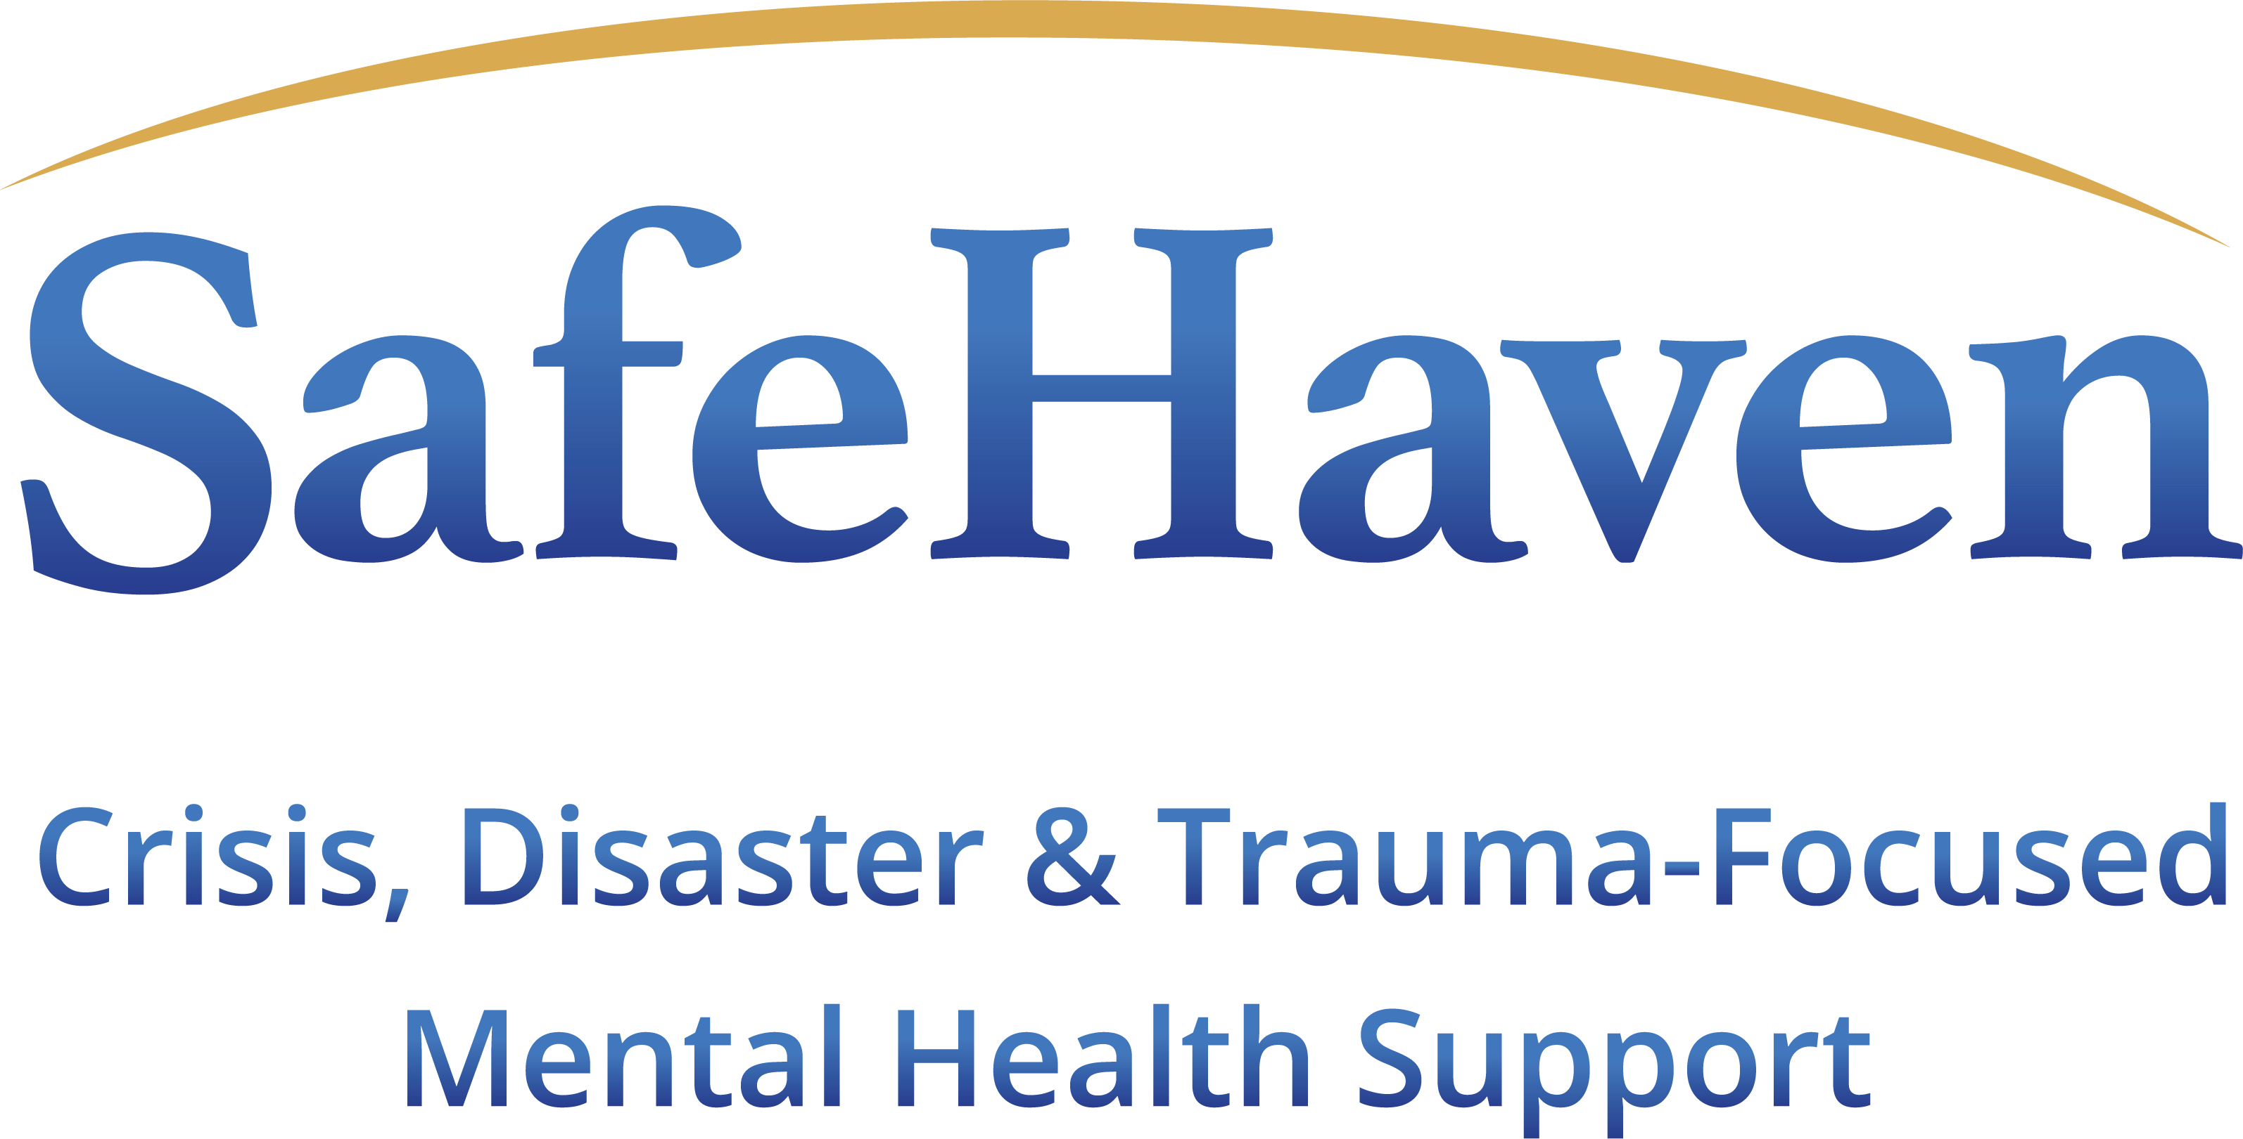
CONTACT INFORMATION:
SafeHaven Critical Incident Stress Management Ltd
Charlotte Copeland – Managing Director
+44 (0)7928 622 722
+44 (0)161 635 1010
Charlotte@safehaven.co.uk
PR ENQUIRIES: Sam@safehaven.co.uk

FOR IMMEDIATE RELEASE
SafeHaven Returns to the International Security Expo to Showcase Psychological Crisis and Disaster Response Services

Manchester, August 2023 – SafeHaven CISM is delighted to return to the International Security Expo 2023, Olympia 26-27 September 2023 for the third year.

Developed by psychologists, SafeHavens Membership plan and App offer a suite of services that provide private and public organisations with comprehensive, robust and flexible solutions—compliant with international standards and best practice guidelines—to care for the psychological welfare of people after a critical incident.

The SafeHaven Membership Service provides ready access to response services and expertise 24/7, 365
days of the year, no matter where and when. Core membership services support both the employer and the
employee in the minutes, hours, days and weeks following an incident of acute trauma to one or multiple employees. From the outset, SafeHaven support organisations in building the incident response strategy that will guide both organisation and impacted individuals through the incident from the very start.

A ‘kick-off’ consultation and assessment allows SafeHaven to identify and tailor appropriate resources
to meet an organisation’s specific needs. A dedicated operations procedure is then established, agreeing key steps and response hierarchy ahead of an incident.

Membership of the service provides a range of tools, resources and access to guidance and support for staff and management across the year, as well as pre-, mid- and post -critical incident.

The service builds on the success of the SafeHaven App, which ensures that employees know what to do to help themselves and others in the vital first few hours and days after an incident or personal crisis.

Not only is the App available around the clock, 365 days a year, but at the touch of a button, it connects users to UK based in-house mental health experts, trauma counsellors and therapists for in-person support when needed. Both immediate, trauma responsive psychosocial support and longer-term psychological sessions can be accessed and arranged confidentially by the user with the SafeHaven team.

In addition, dedicated ‘Hubs’ provide a wealth of expert psychoeducation, including wellbeing videos, playlists, tutorials and guides. This rich depth and variety of expert psychoeducation creates the opportunities for long term behavioural change that reduces stress, anxiety, and really boosts the user’s ability to manage their own mental health.

A management portal helps organisations to tailor, roll out and manage access to the App. This intelligent system provides valuable management information about the health of the workforce, enabling the SafeHaven team to offer guidance on future initiatives, interventions and mitigation measures to stop crises before they begin.

Charlotte Copeland, Managing Director says: “At SafeHaven, we understand the importance of swift, appropriate psychological guidance and support in transforming recovery from physical and emotional distress. The psychological welfare of individuals ripples out to teams and ultimately impacts organisations as a whole. That’s why we not only created an app that goes so much further than others in the mental wellness space, but also a Membership scheme that allows organisations to build a retained response to critical incident trauma into the Duty of Care element of their operations.”

For more information about SafeHaven CISM and the SafeHaven App, visit the team on stand Stand A60.

~ends~

ABOUT SAFEHAVEN CISM

SafeHaven are a multi-disciplinary team of mental health professionals who are all specialists in trauma-responsive psychological mental health care. SafeHaven support organisations and their employees, providing the best in trauma-informed proactive and responsive approaches to psychological wellbeing in the workplace, enabling organisations to provide a package of support that meets best-practice guidelines and international standards.

Core services for organisations:
- Membership service
- SafeHaven App
- Crisis and disaster mental health care
- Consultancy on psychological risk management, policy and SOP development
- Workplace peer-network training
- On-call psychosocial response teams
- Telehealth psychological support

Our team members also act as consultants to the media, supporting productions such as the award-winning documentary ‘Once Upon A Time in Iraq’.

They undertake speaking opportunities as Subject Matter Experts on topics such as:

- Psychological crisis response
- Critical incident training for organisations
- Employee welfare
- Post-traumatic stress disorder
- Workplace and vicarious trauma
- Psychological safety
- Workplace mental health

Our Crisis Response service is verified by the International Critical Incident Stress Foundation (ICISF).

SafeHaven have recently worked with USAID in Afghanistan to design, develop and deliver a free, culturally appropriate trauma recovery educational tool to help communities recover from trauma. Training is available in Dari and Pashto, with separate courses for men and women https://trcr.education/

For more information, please visit https://safehaven.co.uk/

