

Zenitel Launches Zenitel Connect Pro, setting a new standard for cyber secure, unified critical communication solutions

Zenitel, a global leader in Unified Critical Communication solutions, proudly announces the launch of Zenitel Connect Pro, the industry’s first critical communication solution that unifies all types of audio communication solutions, helping to bring safety, security, operational, and infotainment communication needs under one platform.
Cybersecurity demands are fundamental to any security specification today and the Zenitel Connect Pro platform is built on security by design principles, which ensures that cybersecurity is foundational to the architecture, which minimizes potential vulnerabilities and ensures resiliency to cyber-attacks.
By adopting open interface standards, Zenitel Connect Pro makes it easier for security system integrators to incorporate audio into the security mix, including video management and access control solutions, enabling a shift from reactive security to proactive and interactive security solutions.
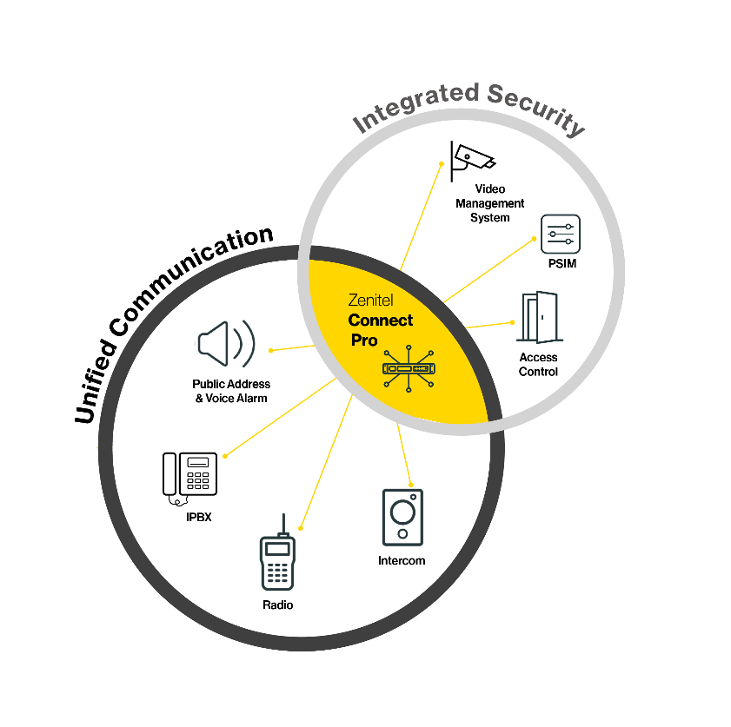
A truly unique offering for the physical security industry
Zenitel Connect Pro represents a paradigm shift in the way people and businesses communicate, transitioning from traditional, siloed communications to a collaborative communications approach, by seamlessly integrating intercoms, IP speakers, public address, and voice alarm systems under a single platform. This unified critical communications approach helps businesses to reduce response times in emergency situations while improving communication resilience by allowing seamless transitions between different communications technologies.

Addressing key operational challenges
Zenitel Connect Pro enables you to setup, deploy, monitor, and maintain your communication system in one place. With a single interface to master, your team spends less time in training. Zenitel Connect Pro is powerful, yet easy to use, with an intuitive interface. This helps you to reduce setup time while giving you full control over your communication assets. Stay secure and up to date on the latest software patches, with a full overview of device software versions.

A new generation communication platform that we will innovate together
By adopting open interface standards, Zenitel Connect Pro will continue to evolve to meet industry demands for new capabilities and cybersecurity requirements. The platform also allows our partner community to further add third-party services on top of functionalities in our core communication platform, further accelerating our development journey.

“We are excited to share this news with our partners and the security industry, and we look forward to helping everyone incorporate critical communication solutions into their security infrastructure,” says Lars Paulsson, EVP for Safety and Security at Zenitel. “This new cybersecure platform opens up opportunities for our entire ecosystem of partners by extending their security offerings with safety communication solutions and enabling the addition of functionalities and services tailored to specific end-customer needs,” Paulsson explains.

For more information about Zenitel Connect Pro, please visit http://www.zenitel.com/ip-speakershttps://www.zenitel.com/zenitel-connect-pro

About the Zenitel Group
Zenitel is the leading provider of unified critical communication solutions that allow people to hear, be heard, and be understood, in every situation. Zenitel solutions are designed to cater to a wide range of safety, security, operational and entertainment needs. Because audio communication is critical in adding interactivity, Zenitel solutions easily integrates with other systems and solution in a seamless manner. To find more about us, visit https://www.zenitel.com

