Zenitel further strengthens its unified critical communication offerings with the addition of new IP speakers
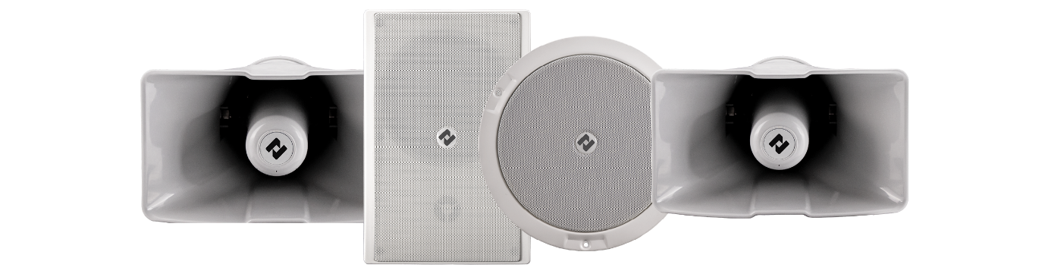

15th of January 2025, Oslo, Norway — Zenitel, a global leader in Unified Critical Communication solutions, proudly announces the launch of new range of IP Speakers, further strengthening its market leadership position within the safety and security communications.
The addition of new IP Speakers, together with Zenitel Connect Pro — the industry's first Unified Critical Communication Platform — paves the way for unifying communication technologies to address life safety, security, and operational communication needs under a single platform.

Built to deliver unparalleled sound quality, Zenitel’s new and innovative IP Speakers feature a high-efficiency power amplifier that delivers a high sound pressure level, making it an ideal choice for high noise environments, in addition to the ability to cover larger areas with fewer speakers.

Bringing voices together with Zenitel IP speakers
Thanks to ONVIF and SIP compatibility, Zenitel’s new IP speakers simplify the integration into security systems, opening new possibilities for communication. Together with Zenitel Connect Pro, the new IP speaker range offers truly unified communication possibilities, enabling seamless communication among security personnel, control room operators, staff, and visitors. With a wide range of use cases, including public address, emergency notifications, security announcements, and background music, the new Zenitel IP speakers transform reactive security systems into proactive and interactive solutions.

At the Forefront of Technology
With up to 123dB SPL output, Zenitel’s new IP speaker range delivers excellent sound clarity for public address broadcasts, even in extremely noisy environments. With the ability to individually addressed, they provide cost-effective PA solutions for medium and small projects without losing zone granularity.
The innovative power supply design, featuring dynamic power management, delivers a full 30W output for voice applications even with standard PoE, eliminating the need for a PoE+ switch. In line with eco-design principles, Zenitel’s IP speakers are optimized to significantly reduce idle power consumption, helping lower energy costs.
Equipped with integrated speaker-as-a-microphone technology, the IP speakers become an essential part of a unified critical communication solution, enabling seamless one-way and bi-directional communication without requiring additional equipment.

Trusted Communication, Protected by Design
Zenitel is committed to ensuring the highest level of cybersecurity across all its technology offerings. Cybersecurity requirements are fundamental to any security specification today. Zenitel provides guidance, advanced technologies, and tools that support the industry's best practices.
Zenitel’s latest IP speakers are no exception. Hardware Root of Trust on IP speakers provides a trusted foundation for verifying the integrity of hardware components, software, and data.
- Secure boot assures that the boot software is approved by Zenitel.
- Verified image upload assures that the software that is uploaded on the device comes with Zenitel approval.

“Last year, with the introduction of Zenitel Connect Pro, we laid a robust foundation for the future of unified critical communication (UCC) offerings. At the beginning of this new year, we are happy to share the launch of a new IP speaker range, further strengthening our UCC offerings,” says Lars Paulsson, EVP for Safety and Security at Zenitel. “The launch of our new IP speaker range marks a significant step in expanding our UCC offerings. As the demand for audio communication solutions grows, we believe these IP speakers will redefine Security, Safety and Operational communication,” Paulsson adds.

With our new IP speaker range, Zenitel reaffirms its commitment to setting industry benchmarks in critical communication, ensuring safety and seamless communication across every environment.

For more information about the new IP Speakers, please visit https://www.zenitel.com/next-generation-ip-speakers

For more information about this product launch, please refer to our release bulletin
https://www.zenitel.com/sites/default/files/2025-01/A100K12303%20IP%20speaker%20range%20changes%20release.pdf

About the Zenitel Group
Zenitel is the leading provider of unified critical communication solutions that allow people to hear, be heard, and be understood, in every situation. Zenitel solutions are designed to cater to a wide range of safety, security, operational and entertainment needs. Because audio communication is critical in adding interactivity, Zenitel solutions easily integrates with other systems and solution in a seamless manner. To find more about us, visit https://www.zenitel.com/safety-and-security

