2N® IP STYLE WINS RED DOT AWARD 2022

March 23, 2022

Red Dot is one of the most prestigious product design awards. This win is yet another argument for your customers to show the 2N® IP Style is the best intercom in the world.

A panel of around 50 experts from all over the world judges each product. And as they say on their website: “Criteria that play a role here include the level of innovation, functionality and longevity.” The 2N® IP Style leads in all these categories, showing that our higher-than-average investment in R&D is the right strategy. 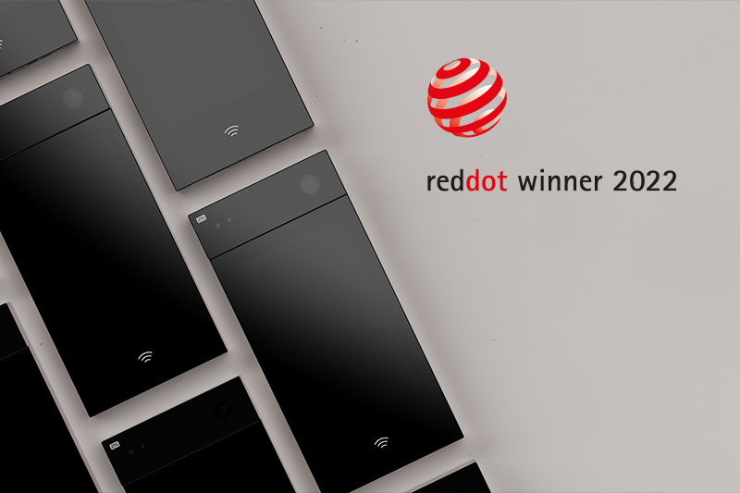
Stay up-to-date with the latest news. Subscribe to our newsletter.

“You could say that the 2N® IP Style is continuing the tradition, following on the heels of the 2N® IP Verso and the 2N® Indoor Touch 2.0, which also previously won the Red Dot Award”, recalls Tomáš Vystavěl, Chief Product Officer at 2N. “I’m proud of all those who have contributed to the development of the 2N® IP Style. This is above all a win for them”, adds Tomáš.
All the products that have ever won the Red Dot Award have one fundamental thing in common, which is their exceptional design. We won’t talk about the dangerously sharp lines, the elegant piano black and luxurious glass finish. Take a look at the magnificent design for yourself in the photo gallery.
https://www.2n.com/en_GB/news/2n-ip-style-wins-red-dot-award-2022

About 2N:

2N is the global leader in IP access control systems.

2N has been in the vanguard of innovation in the sector, developing the world’s first IP intercom in 2008 and the first LTE/4G intercom ten years later. The company’s portfolio includes door phones, answering products and access control systems. 2N specialises in the residential sector and has products which are Bluetooth-, smartphone- and tablet-enabled.

2N takes design just as seriously as innovation – and has the Red Dot and iF Design Awards to prove it.

2N was founded in 1991 in the Czech Republic. Prague remains the global headquarters, with teams now in USA, United Kingdom, Germany, Italy, France, Spain, UAE and an extensive distribution network throughout the rest of the world.

Media contact:
Jan Kapicka
Communication & PR Manager
E-mail: kapicka@2N.com
Tel: +420 225 271 465
GSM: +420 777 639 640
Follow us: Facebook, Twitter, LinkedIn, Youtube, Pressroom

2N TELEKOMUNIKACE a.s.
Modřanská 621/72
143 01 Prague 4
Czech Republic

