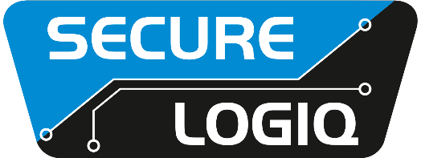

March 2022 For Immediate Release

Secure Logiq wins Toshiba Award

Croydon, UK… Secure Logiq has won the Technical Innovation Award Europe 2021 in the Surveillance Hard Disk Drive category from Toshiba. The two manufacturers have built a long and successful partnership to bring high-quality storage solutions to the surveillance industry.
The recognition is part of Toshiba’s Sales Excellence Awards and was presented on behalf of Toshiba Electronics Europe. When naming Secure Logiq as the award winners, Toshiba expressed its deepest appreciation for the enduring partnership the companies have in the storage business. It also highlighted that together the two manufacturers are helping Toshiba to achieve its Storage Products Division’s mission to enable data storage in the easiest and most reliable way.
“We are delighted to receive this recognition from Toshiba,” said Secure Logiq Sales Director, Ben Yoxall. “We have had a strong relationship with Toshiba over many years and believe that our combined skillsets have ensured surveillance professionals all over the world have the best storage solution for their needs. This award is testament to all the hard work the whole Secure Logiq team has put in and shows the value that we both put on this relationship.”
Toshiba hard disks are a key component of many Secure Logiq servers. The hard disks are available in a range of sizes meaning that Secure Logiq can use them to optimise a server’s performance to the exact requirements of the end user. The positive relationship between the manufacturers has also ensured that Secure Logiq has been able to source the appropriate volume of stock from Toshiba to ensure that it has always kept its promise of delivering systems within 7-10 working days.
“Toshiba are excellent technology partners for Secure Logiq, and together we are creating storage solutions that fit the surveillance requirements of businesses of all sizes,” notes Yoxall. “This award provides another level of motivation for us as we continue our partnership and drive more growth.”

For further information visit: www.securelogiq.com
####

Press Contact:
James Ling, The Inside Story
Tel: +44(0)1892 525141
Email: james@gettheinsidestory.com

About Secure Logiq:
Since 2011 Secure Logiq have been developing the missing piece of the HD surveillance jigsaw, servers specifically designed for HD surveillance. A new concept in the surveillance industry, our team of technical experts have over 150 years of both IP CCTV and server experience and boasts respected thought leaders from both the HD Surveillance and IT hardware industries.
In a short space of time Secure Logiq have become the world's leading independent manufacturer of servers, workstations and client machines optimised for HD Surveillance and Video Analytics applications.
Secure Logiq's company ethos is based on four core principles - to provide the Fastest Performance, the Biggest Storage, the Most Resilience and the Best Value in HD video processing, viewing and storage technology.

