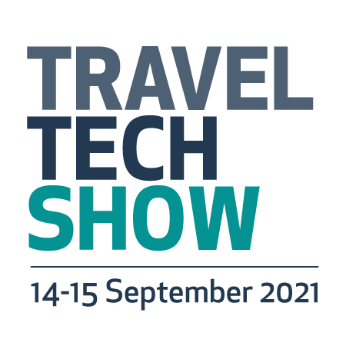

INSERT HEADLINE HERE (USE UPPERCASE)

Sample headlines:
(CO NAME) TO UNVEIL NEW RESEARCH AT TRAVELTECH SHOW
(CO NAME) TO LAUNCH NEW PRODUCT AT TRAVELTECH SHOW
(CO NAME) TO EXHIBIT AT TRAVELTECH SHOW FOR FIRST TIME
(NAME) TO SMASH SHARING ECONOMY MYTHS AT TRAVELTECH SHOW CONFERENCE

Insert subheading here to expand on headline and possibly include URL (Use sentence case)

Sample sub:

Visitor registration now open for TravelTech Show at traveltech-show.com

Insert date here: Your news should be written succinctly in the first paragraph – always work on the assumption that the journalist may not read beyond these first few sentences. Stick to facts. Write in the past tense.

Sample opener: Travel Company A (you can insert a hyperlink to your site here) is exhibiting at TravelTech Show for the first time in 2021 and will use the event as a platform to launch brand new technology that has the potential to revolutionise the way travellers xxxxxxxxxxxxx.

Following paragraphs: Expand on the story, tell them more about the product and why it’s amazing.

Quote: Add in quote from your spokesperson, avoid hyperbole and include information that genuinely adds to the story – in past tense and the below format. If you can include a special offer in your press release that’s exclusive/specific to the show all the better.

Sample quote: “This product has been in development for the last three years and we believe it’s more effective than anything similar currently on the market,” said Fred Blogs, managing director, Travel Tech Company A.

“We are throwing the gauntlet down to buyers who place an order at the show – use it for three months, and if you don’t manage to cut your costs by more than 10 per cent in that time, we will give you your money back and a year’s free license.”

End with something like: Buyers can find Travel Company A on at TravelTech Show, which takes place virtually between 14-15 September 2021. Visitor registration is open now at traveltech-show.com

Boiler plate: Insert your boiler plate here. Below is the TravelTech Show boiler plate.

About TravelTech Show:
TravelTech Show, previous known as Travel Technology Europe, brings together global decision-making technology buyers to help them find new innovative technology solutions for their travel business. ​
The specialised virtual exhibition and conference brings together thousands of travel technology professionals. The event has a long history and strong reputation connecting travel technology buyers and managers with the suppliers, knowledge and contacts to help innovate for the future of travel.
Running alongside the exhibition is an ambitious conference programme that follows the sun, each day starting off in Signapore and Middle East with content delivered by WiT, then the UK and mainland Europe and finishing each day in USA with content delivered by Phocuswright. Supported by over 120 expert speakers, the topical sessions cover the full spectrum of travel technology facilitating peer to peer learning and debate to enable companies to drive the industry forward.
TravelTech Show enables technology buyers from across the global tourism sector to easily improve their tech stack and plan ahead, by gaining access to global suppliers and local disrupters to discover new micro and macro trends to future-proof their strategy and achieve their business objectives.
Join a community of innovators, benchmark performance and uncover new ways to increase efficiencies, drive revenues and learn how to improve your customer retention.

For media information:

Add in your media contact name and details.

