Presented by: | 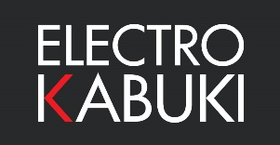

New Rigging Company Makes Early Investment in Electro Kabuki to Drive Expansion.

An industry veteran of more than 20 years and famed for his work as head rigger on BBC’s ‘Strictly Come Dancing’, rigging specialist Erlend Webb recently established his own business and made an investment in Electro Kabuki (EK) one of his first actions.

Erlend set up Webb’s Rigging Ltd in March 2020, unfortunately coinciding with the arrival of the first coronavirus lockdown. Despite the difficulties imposed by Covid on the event industry, his reputation and expertise have kept him busy since the company’s inception.

Webb has used the Electro Kabuki system many times over the years, predominantly with his work in TV using rented EK systems or EK kits belonging to studios or venues. The dependable system became his kabuki drop solution of choice for all rigging projects that required curtains, drapes or props to be released with precision timing.

With the success of his new venture, Webb has expanded into the live event and film-based sectors. In both, absolute performance integrity and equipment reliability is paramount. “You cannot risk a failure in a live event,” he explains. “The dependability of your rigging is absolutely critical. Based on that need and my first-hand experience, Electro Kabuki was the only choice for me.”

Webb invested in the Electro Kabuki Starter Pack and specified extra-length connecting cables to cater for the long runs he encounters in rigging sets in TV studios. “The EK Starter Pack is available ex-stock for speedy delivery and works straight out of the box. It gives me exactly what I need for our current projects, including the rigging of props to drop onto the set of ‘Cats Does Countdown’,” he reports. “The plug & play EK system is highly modular, so I can simply add more components as I need them and plan on doing that soon.”

ENDS

Image attached: The basic Electro Kabuki Starter Pack. (File name: Electro Kabuki Starter Pack.png)

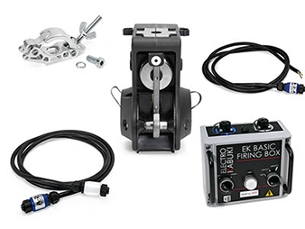 (thumbnail for reference).

About Electro Kabuki
https://electrokabuki.com
Electro Kabuki (EK) is designed and manufactured in the UK by a leader in the design and development of special-purpose electric locking & holding mechanisms and electromagnet subassemblies, Magnet Schultz Ltd (MSL). Electro Kabuki is a proven theatrical reveal system that features industrial-grade precision engineering at its heart. It provides a sophisticated but exceptionally easy-to-use configurable system that precisely meets exacting event requirements for faultless and dependable curtain drops, drape reveals and kabuki drops. MSL is the UK arm of the Magnet-Schultz Group headquartered in Germany, an international engineering group dedicated to manufacturing high-tech electromagnetic actuators and sensors, and the world’s leading solenoid manufacturer.

Electro Kabuki Company Contact | Swordfish Marketing Contact
Tim Lloyd  Electro Kabuki  Magnet Schultz Ltd  3-4 Capital Park  Old Woking  Surrey  GU22 9LD | Tina Gagg  Senior Account Manager  Swordfish Marketing  First Floor  10 King’s Head Place  Market Harborough  LE16 7JTB
[t] +44 (0)1483 794700  [e] tlloyd@magnetschultz.co.uk  [w] www.electrokabuki.com | [t] +44 (0)1858 437743  [e] tinag@swordfish-marketing.com  [w] www.swordfish-marketing.com

