Presented by: | 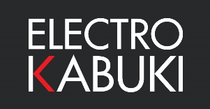

Online Ordering Announced for Electro Kabuki Systems & Parts.

The team behind Electro Kabuki announces the successful first phase development and launch of a programme to enhance the Electro Kabuki website. The site at https://electrokabuki.com now offers an online ordering and payment facility covering the entire range of Electro Kabuki systems, components, accessories and spares for UK delivery.

By adding eCommerce and shopping cart functionality to the familiar Electro Kabuki website, web visitors can now select from over 20 different products lines including Starter Packs, Flight Cases, individual Electro Kabuki dropper modules and an array of accessories.

In this first enhancement phase, online ordering and delivery is limited to destinations in the UK, with ex-VAT prices listed in Pounds Sterling. The second phase will see this functionality rolled out to other geographic territories and currencies.

“The shopping function is live and working,” explains Electro Kabuki Product Specialist Tim Lloyd. “For now, our online operations only scope the UK while we fully appraise our shopping cart technology. People trust Electro Kabuki with proven engineering expertise at its heart and this must apply equally to our online transactional procedures. Once we are satisfied, we plan to extend the scope of online ordering and payment.”

Overseas Electro Kabuki users can still use the website to select items and automatically assemble and submit a list of materials to obtain a quotation that will include shipping costs in local currency. Links to the ‘Get a Quote’ section are clearly visible from the new ‘Store’ page. For UK destinations, the shopping cart automatically accounts for weight to calculate shipping charges for delivery by secure courier within 3 to 5 business days.

ENDS

Image attached: New Store web page for online ordering of Electro Kabuki systems and parts. (File name: EK online store.jpg)

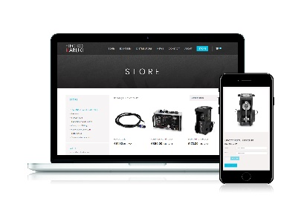 (thumbnail for reference).

About Electro Kabuki
https://electrokabuki.com
Electro Kabuki (EK) is designed and manufactured in the UK by a leader in the design and development of special-purpose electric locking & holding mechanisms and electromagnet subassemblies, Magnet Schultz Ltd (MSL). Electro Kabuki is a proven theatrical reveal system that features industrial-grade precision engineering at its heart. It provides a sophisticated but exceptionally easy-to-use configurable system that precisely meets exacting event requirements for faultless and dependable curtain drops, drape reveals and kabuki drops. MSL is the UK arm of the Magnet-Schultz Group headquartered in Germany, an international engineering group dedicated to manufacturing high-tech electromagnetic actuators and sensors, and the world’s leading solenoid manufacturer.

Electro Kabuki Company Contact | Swordfish Marketing Contact
Tim Lloyd  Electro Kabuki  Magnet Schultz Ltd  3-4 Capital Park  Old Woking  Surrey  GU22 9LD | Tina Gagg  Senior Account Manager  Swordfish Marketing  First Floor  10 King’s Head Place  Market Harborough  LE16 7JTB
[t] +44 (0)1483 794700  [e] tlloyd@magnetschultz.co.uk  [w] www.electrokabuki.com | [t] +44 (0)1858 437743  [e] tinag@swordfish-marketing.com  [w] www.swordfish-marketing.com

