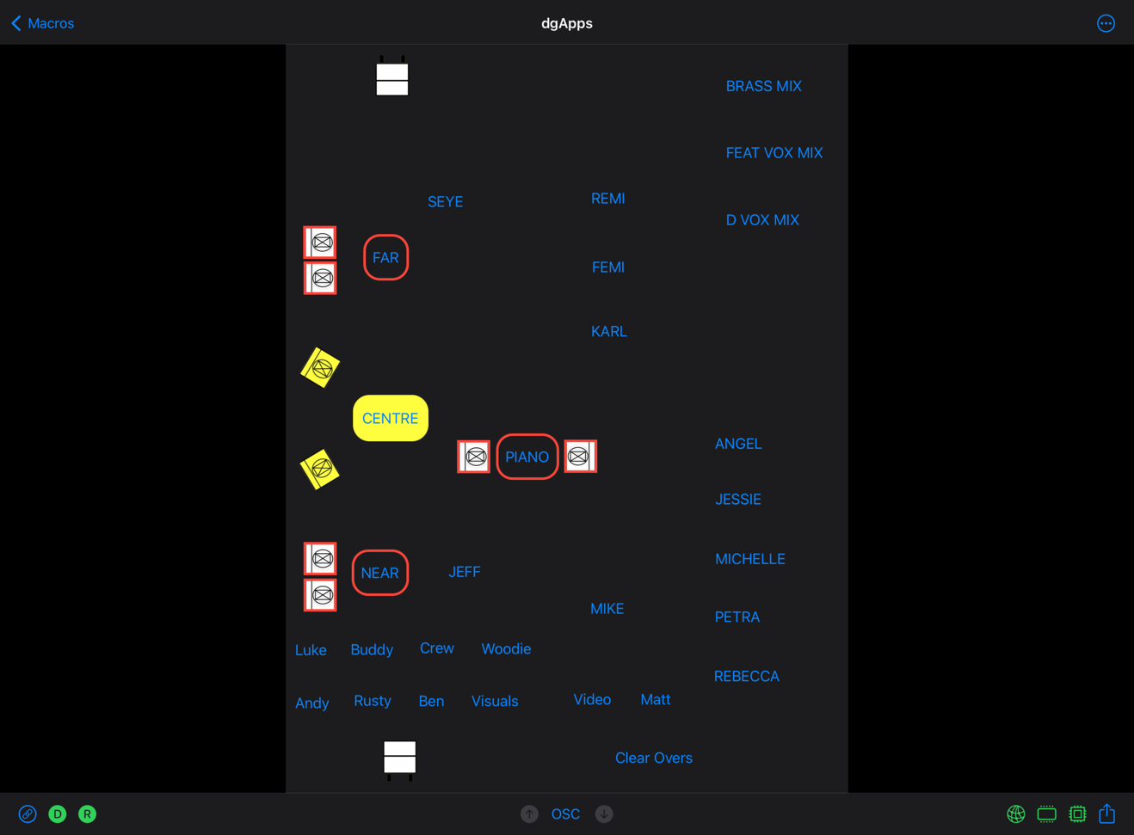
Macros by dgApps is an iPhone and iPad app that fires macros on DiGiCo SD or DiGiCo Quantum audio mixing desks. Use the iPhone that's in your pocket to fire desk macros, no Stream Deck and Raspberry Pi required. Although still in beta, dgApps will be showing Macros at PLASA Show 2022 alongside Router and Faders which are available on the App Store today.
Macros are displayed via stage plan screens and button screens. A Macros session can have multiple stage plan screens and multiple button screens.
Macros stage plan screens are fully editable. Items on screen can respond to aux send pfls and aux send mutes from the desk, so you can always see what's happening even if your aux outputs are on a bank of faders not currently on the desk surface. Each item on screen can fire one desk macro, and items can be grouped together to fire their macro and respond to an aux pfl and mute as one.
Macro button screens are also fully editable. Buttons can fire one macro or many macros in sequence. Buttons can also be grouped together so that a common off macro is fired before the specific button macro is fired.
Macros is currently in use on the Gorillaz World Tour 2022, which is heading to North America for seven weeks directly after PLASA Show 2022.

https://dgapps.ie/
dave@dgapps.ie

