
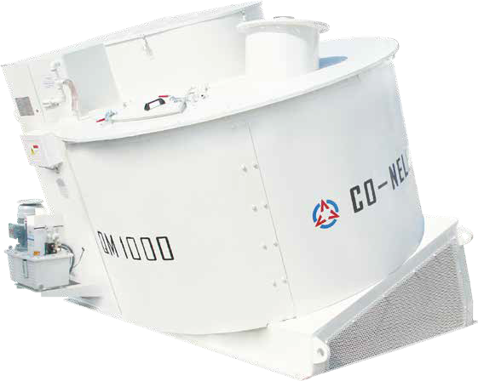

UK Ltd.

Intensive Mixer


Mixing, granulation, reaction, emulsification, dispersion, separation, plasticizing, forming, exhaust, crushing, fibrosis, decomposition, coalescence.




www.co-nele.co.uk


Company Profile

Co-Nele UK Limited are the UK’s sole agent for CO-NELE Machinery based at Staffs Powder Processing. Units 7 - 10 Hobson Street, Burslem, Staffordshire. ST6 2AW.
CO-NELE provides high quality products throughout China and exports to more than 80 countries and regions from Europe, America, Asia, Africa, and Australasia.

The UK distribution arm is operated by Staffs Powder Processing Limited, who specialize in the agglomeration of powders into spherical granules and offer a variety of toll processing services that include:
Milling, Blending, Bagging, Agglomeration, Sieving and bespoke production.

Many projects start and develop at our specialist R&D facilities, where we take customers materials and concepts and develop them into products.

We have successfully produced aggregates and fertilisers from over two dozen waste streams including:
- Lime quarry waste
- Agricultural incinerator ashes
- Waste glass
- Sewerage digestate
- Fly ash
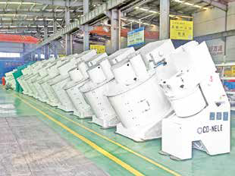
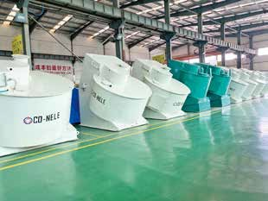
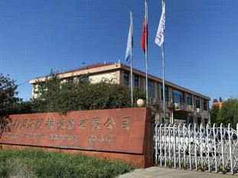
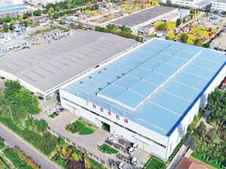


Product Introduction
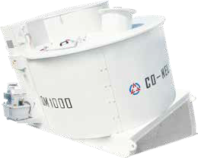
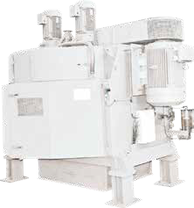
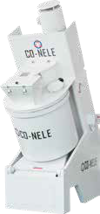
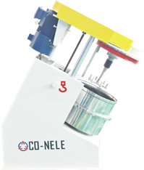
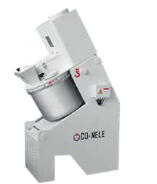
Intensive mixers
The unique mixing principle of the series of Intensive mixers ensure constant, reproducible product quality with minimal mixing times for batch operations.
The mixer is inclined at a certain angle to realise a three-dimensional stirring mode, so that the material is turned more consistently, and the mixing is more uniform. The mixing direction is divided into forward and reverse.
Our intensive mixers are ideally suited to produce aggregates and fertilisers. We offer our potential customers the opportunity to view the machines in operation at our Staffordshire based production facilities.
The mixers can perform a variety of tasks which include: -
- Perform an intense blending of materials to give a uniform final product
- Produce a micro seed to help with the flowability of materials
- Produce spherical granules in the size range of 1 -8 mm depending on customer requirements
- Produce wet mixes for further processing such as extrusion, compaction and pressing.

CR/ CEL series Intensive mixer
CEL series Intensive mixer are laboratory mixers with a size range from 1 to 10 liters are available. CR series Intensive mixer sizes from 5 to 50 liters are also available.
Flexible high-performance mixing system for challenging tasks in the fields of research, development, and small-scale production.
The multi-functional mixing system can be used for many different applications,
e.g. for mixing, granulating, coating, kneading, dispersing, dissolving and many more.


Lead to the future of mixing

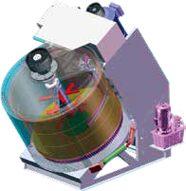
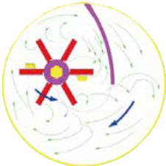
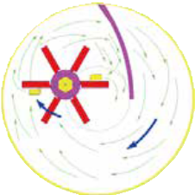

Intensive mixers can be designed according to countercurrent principle or cross flow principle.
Intensive mixing can guarantee the following three points
The mixer bowl and the rotor move together. At the same time, the mixing device can cut, blend, and mix the material in a complex mixing cycle, giving a very good mixing effect.
As material passes over the bottom scraper it is turned over and mixed in a vertical upward motion.
The fixed scrapers inside the drum also perform a cleaning action reducing the build up of wet and sticky material.

Technical data



Mechanical Features

1 Gearing system
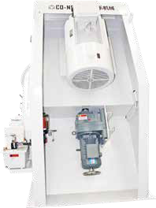
We can specify the appropriate motor sizes and speeds to suit all manner of applications.
Options include original motors, European motors or supplied for customers to add their own specified motors.

2 Mixing device
While the material is rotating with the mixing drum, a force is generated between the mixing drum and the mixing device that is rotating the opposite direction in the centrifugal position. The wolfram carbide compounded liner ensures a durable quality and an easy maintenance.

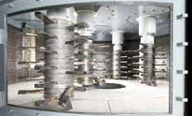
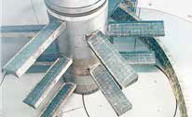
The design and quantity of the mixing blades depends on the material type and abrasiveness. The blades are also easy to replace.

The advantages
The machine mixes without demixing effects; 100 % material circulation during one rotation of the mixing pan
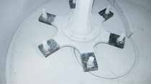
Optimal mixing effects are achieved with only one mixing tool.
Various consistencies can be processed in the mixer.
High mixing quality is reached even with short processing times.
Scale-up of research and development test results
Have proven to be very successful.

We can offer ware resistant parts for abrasive applications including Carbide coating, ceramic and
rubber coatings and carbide cladding.

3 Discharge door
Larger models operate a centrally positioned bomb door which opens and closes whilst the drum is rotating. The rapid discharge of material ensures a high throughput of mixes.

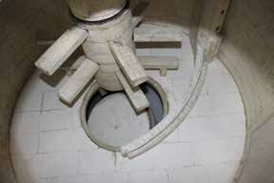
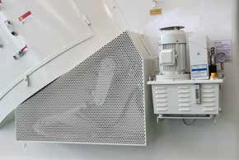

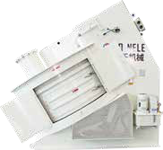
4
Maintenance Door door
Our industrial range of mixers have a side inspection door to allow for easy access and parts maintenance.
The drum is protected by a circular safety guard ensuring no moving parts can present a danger to operators.

Applications
Aggregates
Waste quarry fines, limestone, fly ash and industrial wastes and by-products from emerging technologies to replace the diminishing supplies from the steel and power industries.
Ceramics
CO-NELE Intensive mixers can be used to mix, homogenise, granulate, plasticise, suspend, cool or heat as well for reactions – and all this in a single machine.

Molding compounds, molecular strainers, proppants, varistor compounds, dental compounds, cutting ceramics, grinding agents, oxide ceramics, non-oxide ceramics, composite materials, silicate technical ceramic grinding balls, ferrites, etc.
Refractory
CO-NELE has been the leading supplier of cutting-edge technologies for the preparation of refractory compounds.
Shaped, Unshaped products, Prefabricated parts, Mixtures and granules for oxide and non-oxide ceramic material, mixtures for ceramic fiber materials.
Concrete
Porous media of bricks, expanded clay, perlite, etc., refractory ceramsite, clay ceramsite, shale ceramsite, ceramsite filter material, ceramsite brick, ceramsite concrete, etc.

Glass
Glass powder, carbon, lead glass mixtures, waste glass slag etc.

Metallurgy
When processing raw materials to produce green pellets, ultrafine ores are mixed with binding agents (e.g., bentonite) and aggregates (e.g., limestone or dolomite). Zinc and lead ore, aluminum oxide, silicon carbide, iron ore, etc.
Fertiliser
Lime hydrate, calcium carbonates, dolomite, sulphates, phosphates, biochar and many more.

Environmental technology
Fly ash, slag, dust, sludge, cement filter dust, fly ash, slurries, dusts, lead oxide, Phosphates gypsum etc.



Co-Nele Intensive Mixer in operation at British Gypsum Fauld Mine UK.

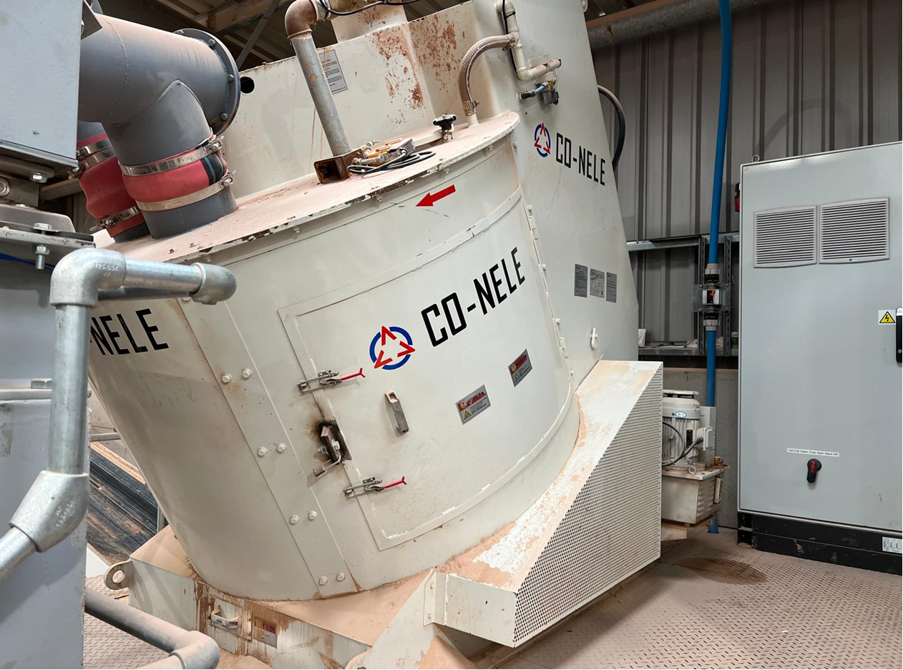

Contact Details
Website: www.co-nele.co.uk

Email: Enquiries enquiries@co-nele.co.uk

Contact Details:
Matthew Evans 07875 678732
Jim Evans 07760 676568
Gary Hunt 07888 829584

Co-Nele UK Limited
Units 7–10 Hobson Street,
Burslem,
Staffordshire.
ST6 2AW

We also supply a full range of Co-Nele Planetary mixers, please contact us for further information.

