

Planetary Mixer

High efficiency and high quality, low maintenance

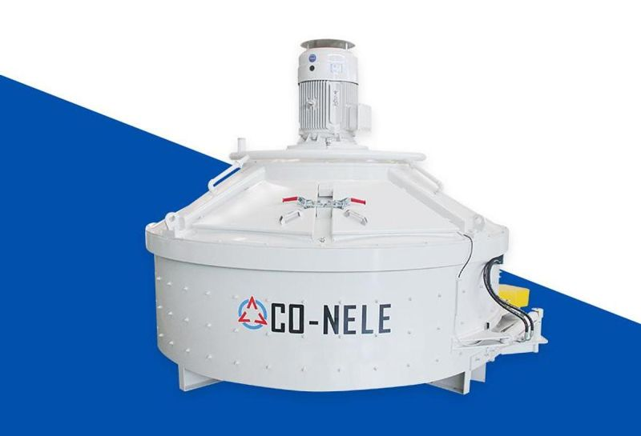

Company Profile

Co-Nele UK Limited is the sole agent for Qingdao CO-NELE Machinery Limited and are based at Staffs Powder Processing, Units 7, 8 & 9 Hobson Street, Burslem, Staffordshire. ST6 2AW.

Co-Nele Machinery is one of the national science & technology innovating enterprises located in Qingdao, a beautiful coastal city in China. Co-Nele Machinery is a most professional company and ranks among the top of the mixing equipment manufacturers with its products applied worldwide, based on advanced European technology, we keep close eye to the state-of-the-art technology and our competitors, keeping ahead of the market. We pay great attention to product research and development, and till now have gained over 40 national patents. CO-NELE follows strictly to the IS09001 Quality Management System and is the first company who got the CE certificate in the same industry In China. CO-NELE provides high quality products throughout the country and exports to more than 50 countries and regions from Europe, America, Asia, Africa, and Australasia.

- The first company who got CE certificate in the same industry in China.
- Shandong famous trademark,
- A fullest model range of planetary mixer manufacturer.
- With the First entirely oil-immersed gear box equipped in planetary type mixer in China.
- A professional manufacturer with the most widely product application domain in China.
- The largest production base planetary mixer In China.
- A promoter for environmental-friendly and low-carbon mixing equipment
- The largest exporter of planetary mixer In China.
- China non-standard mixing equipment design research and manufacture center.
- The largest and the smallest planetary mixer are both born In CO-NELE.
- China' s most independent intellectual property rights owner of the planetary mixer.
- The strongest design and manufacturing capability is a planetary mixer manufacturer.

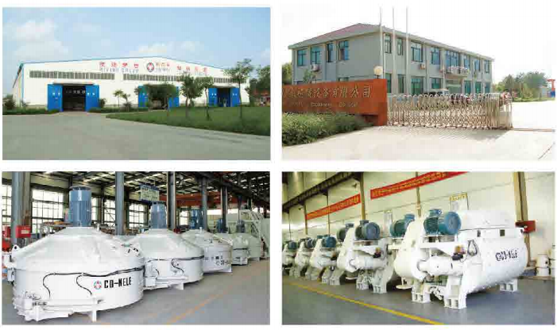

Product Introduction

Compact Construction, steady driving, original mode, excellence in performance and long operating life. With low investment and operational costs, easy to install and maintain with no leakage problems and leading products.

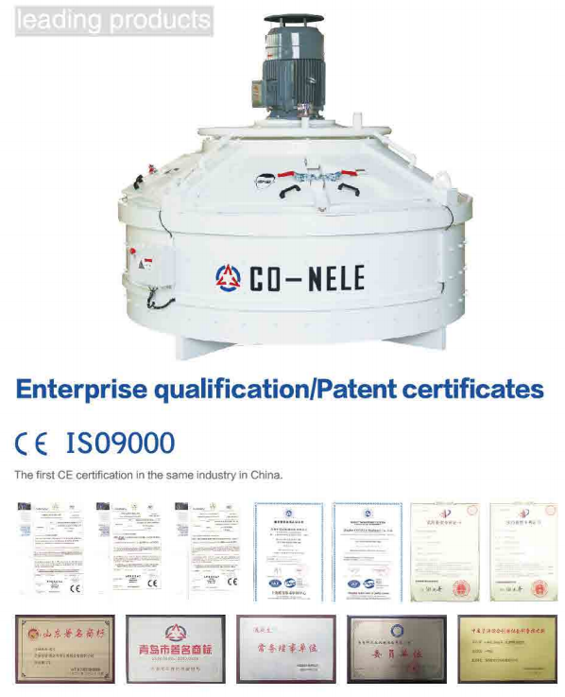

Planetary Mixer Configuration

1 Gearing System.
The driving system consists of motor and hardened surface gear which is specialized designed by CO-NELE (patented). Flexible coupling and hydraulic coupling (option) connects motor and gearbox. The gearbox is designed by CO-NELE (completely Independent Intellectual property rights owned) absorbing European advanced technology. The improved model has lower noise, longer torque and is more durable. Even in strict production conditions, the gearbox can distribute power effectively and evenly to each mix end device, ensuring normal operation, high stability, and low maintenance.

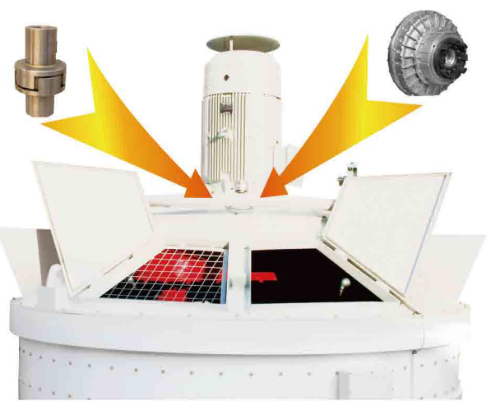

2 Motion Track.

The revolution and rotation speed of the blades have been extensively studied and tested to give the mixer a high output without causing the segregation of materials with different grain size and weight. The movement of the material inside the trough is smooth and continuous. As shown in the picture, the blades track covers the whole bottom of the mixing bowl after a cycle.

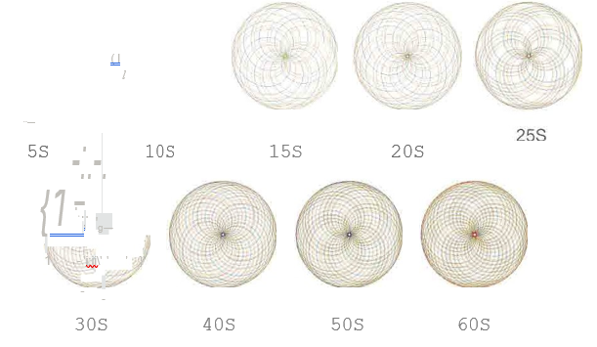

3 Observing Port.
There is an observing port on the maintaining door. You can observe the mixing situation without cutting off power,

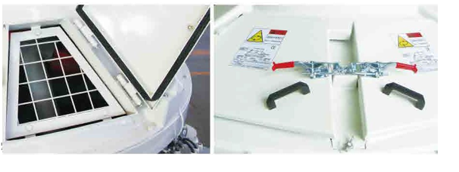
4 Mixing Device.

Compulsory mixing Is realised by composite movements of extruding and overturning, driven by rotating planets and blades. Mixing blades are designed in parallelogram structure(patented), which can be turned 180° for reuse to increase service life. Specialised discharge scraper has been designed according to discharge speed to increase productivity.

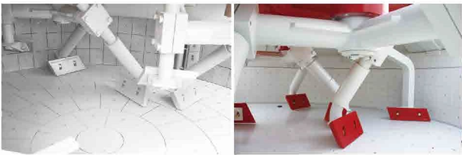

5 Discharging Device.

According to the different demands of customers, the discharging door can be opened by hydraulic, pneumatic or by hand. The number of discharging doors is three at most. And there Is special sealing device on the discharging door to ensure the sealing reliable.

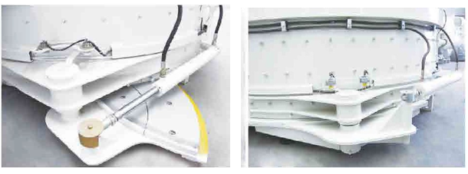

6 Maintenance Door and Security Device.
To Improve the security of using the product, reliable high-sensitive security switches are used in the maintenance door to make the maintenance work safe and convenient.

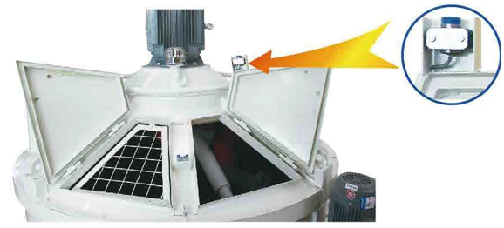7 Water Device.

Overhead structure ls used to water (patent products). It solves the problem of residual additives and water in the pipes. Avoid customer loss in formula changing. The nozzle Which adopts spiral solid cone nozzle, has a fine uniform atomisation effect, large covering area and make the material more uniform when mixing.

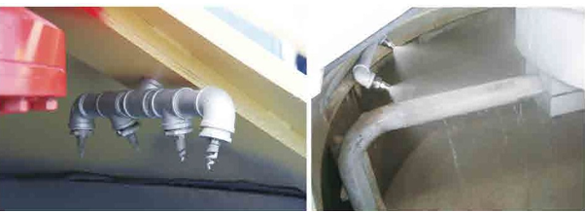

8 Experimental Test Center.
We have a testing center for all kinds of material to meet the customer’s different material types for mixing.

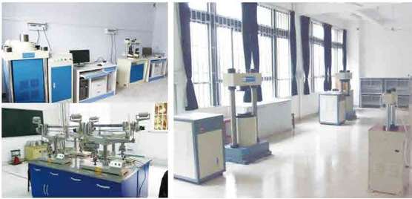

Technical Data

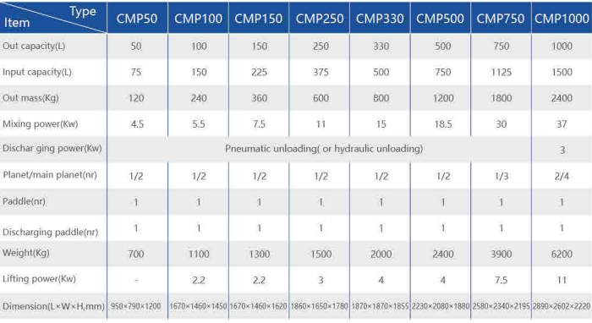
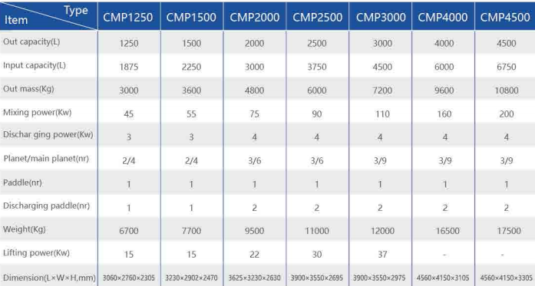

Planetary fly-cutter mixer configuration

Mixing blades are designed in parallelogram structure(planted), which can be turned 180° for reuse to increase service life. Specialised discharge scrapers have been designed according to discharge speed, to Increase productivity.

1 Mixing Device.

Mixing blades are designed in parallelogram structure(planted), which can be turned 180° for reuse to increase service life. Specialised discharge scrapers have been designed according to discharge speed, to Increase productivity.

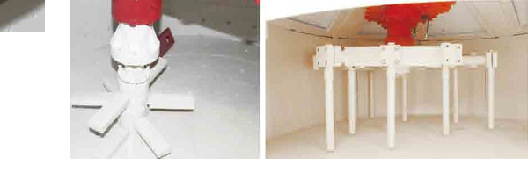
2 Motion Track.

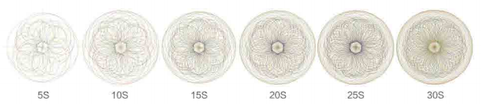

Control System

We provide two modes of control system. The first mode consists of an industrial computer, weighers, control cabinet and high voltage cabinet. The second mode Is made up of PLC, touch screen, weighers, and control cabinet. Both modes adopt man-machine interface, menu options, fully automatic control of material ratio. Multiple displays of different working process makes it easy to monitor and manage production. Easy operation owes to the beautiful outline design and humanized control method. All electrical components are from famous foreign brands to ensure the stability of the system. The control system has a wide application. Each weigher signal collected by independent weighing Instrument, transferred by serial communications to specialize computer control board collecting external digital signals and realizes automatic production. High precision, strong anti-jamming capability. Besides customized services are approved.

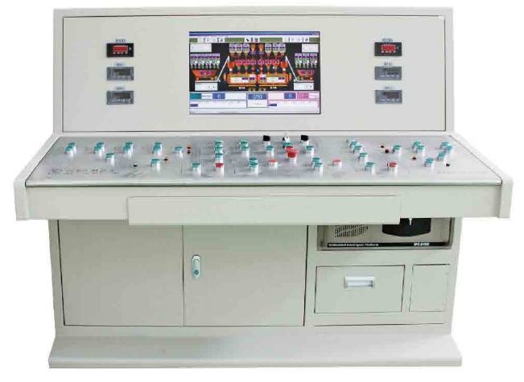

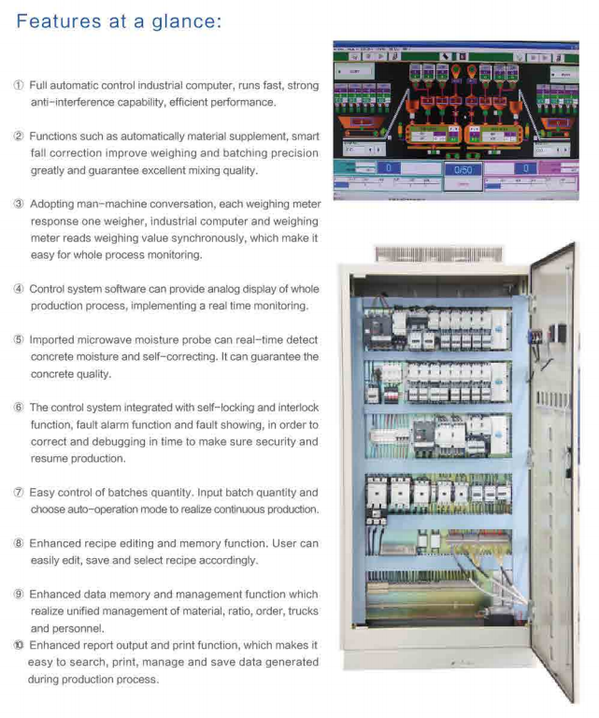

Optional items

1 Skip hoist and weighing system.
Planetary mixer equipped with skip hoist and weighing system. The inlet will open and close automatically when skip hoist lift to the inlet or descend (Patent), preventing dust from coming out of mixer as a result of Environmental controls. Cement scale and water scale (Include precision measurement) are designed very reasonably. Weighing is more accurate.

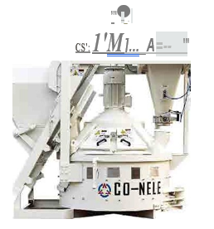

2 Environmentally Friendly Anti-Block Feeding Device.

Specially designed environment-friendly anti-block feeding device(patented). The design of the outer slide rail prevents the Inlet gate from blocking and leads to better sealing.
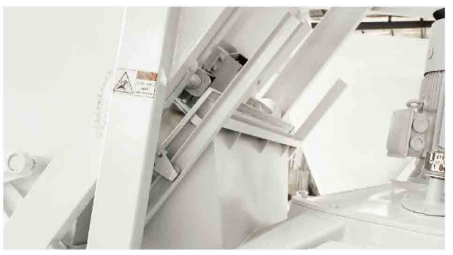

3 The Security Device of Skip Hopper.
The security device of skip hopper safeguards against head injury when the hopper is travelling upwards.

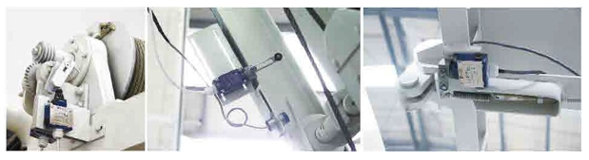

4 High Pressure Washing.
Automatic high pressure cleaning system washing with the use of a rotating high pressure nozzle that only takes several minutes, cleaning the mixer walls, mixing tools and the entire interior. This greatly improves the cleaning effect, reducing cleaning times and labour and improves the working environment.

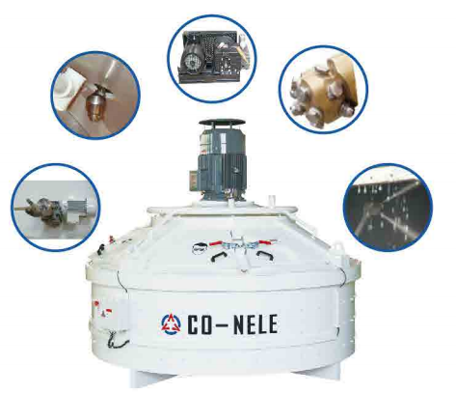

5 Temperature and Moisture Sensor

High precision and dynamical measuring supplies accurate value of temperature and moisture, which can achieve better performance of the mixture.

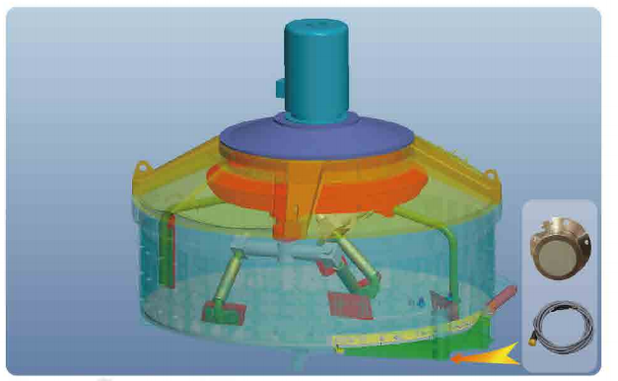

Applications

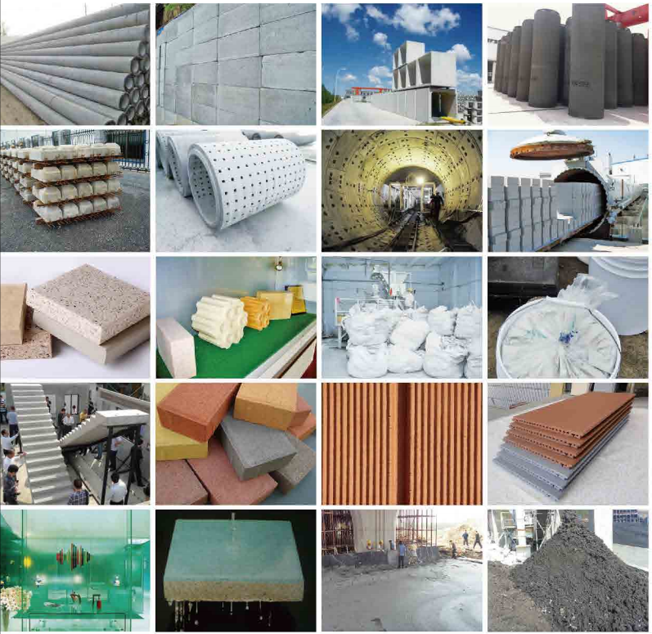

Projects
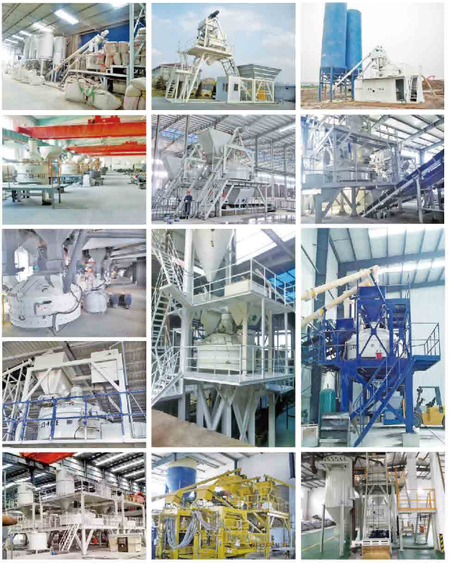

Website: www.co-nele.co.uk

Email: Enquiries enquiries@co-nele.co.uk

Contact Details:
Matthew Evans 07875 678732
Jim Evans 07760 676568
Gary Hunt 07888 829584
Amy Evans 07904912585

Co-Nele UK Limited
Units 7–10 Hobson Street,
Burslem,
Staffordshire.
ST6 2AW

We also supply a full range of Co-Nele Intensive mixers, please contact us for further information.

