MEDIA INVITE - THE BIG LAUNCH AT HILLHEAD WITH HD HYUNDAI

Dear Editor,

The team at HD Hyundai Construction Equipment would like to invite you to attend the UK press launch of our biggest Stage V excavators and wheel loaders, at the Hillhead Exhibition near Buxton. Please come along to our biggest stand (Z5) at 11.00am on Tuesday June 25th to hear about these important developments to the HD Hyundai range.
Following a brief market overview, we will have a walk-around of the new HX1000A L 100-tonne excavator and the HL985A wheel loader. Product experts will be available throughout the day for media interviews and to provide any additional information that you may require.
Come and grab a bacon sandwich and a tea or coffee, or come back for one of our famous pies, while taking in the view of the main working area from our new home at Hillhead, Stand Z5.

Dan Gilkes.

Press Office
HD Hyundai Construction Equipment Europe
M (+44) 07802 751473
pressoffice@hyundai.eu
www.hyundai.eu
Hyundailaan 4
B-3980 Tessenderlo

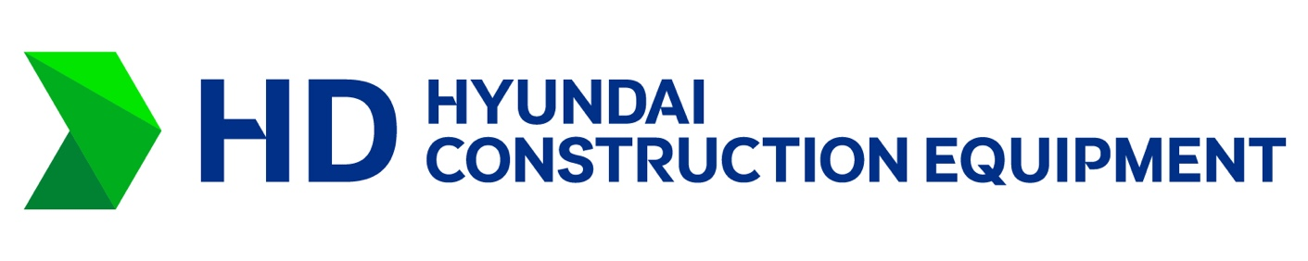

HD Hyundai Construction Equipment Europe is a widely recognized leader in the European construction equipment market. Through highly advanced factory automation, a zero-tolerance quality control inspection system and innovative engineering we offer a wide range of construction equipment to satisfy the demands of our customers. We manufacture heavy equipment for our Construction Equipment business unit including hydraulic excavators and wheel loaders. Through our Material Handling business unit, we offer a wide range of forklifts (including LPG, electric and diesel-powered lift trucks) & warehouse equipment to satisfy customers’ ever-growing demands. HD Hyundai Construction Equipment Europe markets its products through a qualified network of over 140 dealers in more than 30 countries. For additional information, please visit www.hyundai-ce.eu

