ABOUT US
Derbyshire Geotechnical Ltd is a specialised Geotechnical Rope Access Company offering a wide variety of bespoke services whilst working at height and striving for excellence.
Based in the heart of the Peak District, we are a well established and professional company offering a wide range of Rope Access Geotechnical Services.
We aim to provide a safe, reliable and professional service to all our clients in the UK and further afield. We are proud to say our clients include: Local County Councils, AMCO-Giffen, Breedon Aggregates, Heidelberg Materials, Aggregate Industries, Keller Geotechnique, National Trust, TATA Steel and TARMAC, amongst many others.
We offer a broad range of services, undertaken by fully qualified managers, supervisors, IRATA technicians and sub contractors. Services include de vegetation, large and difficult tree removal, rock anchoring, soil nailing, slope stabilization and installation of rockfall mesh and erosion matting, inspection and repair of previously installed rockfall protection, supporting and enabling geotechnical and ecological surveys and inspection etc.
This enables us to design and build tailormade projects to suit our client’s needs. For your peace of mind and security we hold appropriate insurance and all the relevant health, safety, environmental and quality accreditations.
The experience of our work force in the industry is second to none and we are proud of our commitment to them and our customers.
Company Registration No: 10857442
OUR MISSION STATEMENT
D - Dedicated to providing a service that goes above and beyond to all our clients
G - Guaranteed to deliver projects on schedule and at competitive prices.
E – Experienced in wide range of Geotechnical Services with safety and professionalism at the forefront
O – Operatives who are qualified, experienced and responsible for your peace of mind.
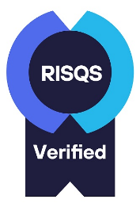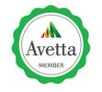
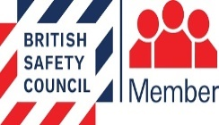

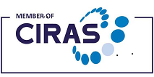

C/O TORR CROFT, PITTLEMERE LANE, TIDESWELL MOOR, NR BUXTON, DERBYSHIRE SK17 8JF
E MAIL – info@d-geo.co.uk
WEB SITE – www.d-geo.co.uk
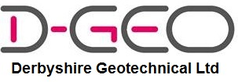
“MESHING WITHOUT MITHER”
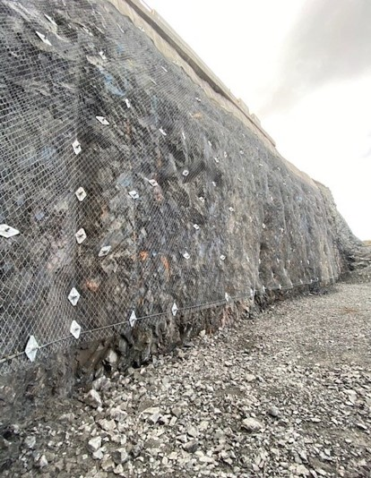
Geotechnical Rope Access
Service Providers.
Quality, Safety and Value is our Priority
TELEPHONE - 01298 931030
MOBILES - 07598 790670 / 07572 138747 07946 645653

OUR SERVICES
Rock Face Stabilisation
- Rock scaling & Re-profiling
- Dentition work
- Rock bolting & dowels
- Rock anchoring
- Installation of rockfall mesh
- Sprayed concrete
Slope Stabilisation
- Soil nailing
- Facing systems
- Slope drainage
- Installation of erosion matting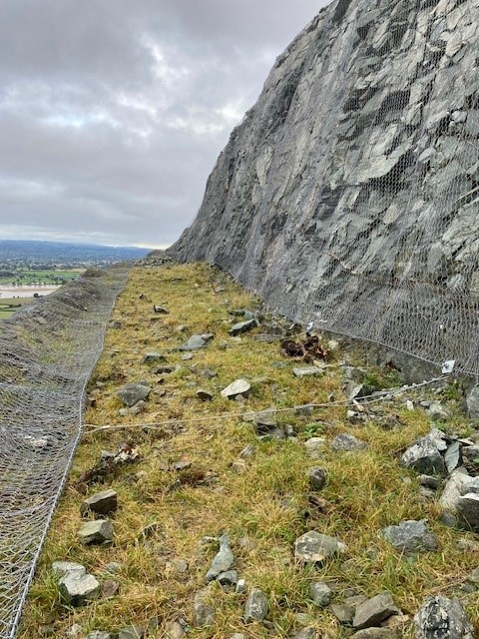
OUR SERVICES
Facing Systems
- Encourage vegetation growth
- Enhances stability of soil slopes through soil retention
Inspection & Maintenance of Slope and Rockface Stabilisation Installations
- Inspection works & inspection reports
- Repairs & maintenance work.
Rock Fall Containment
- Catch fences
- Debris (Barrier) Fences
- Rock fall netting & meshing
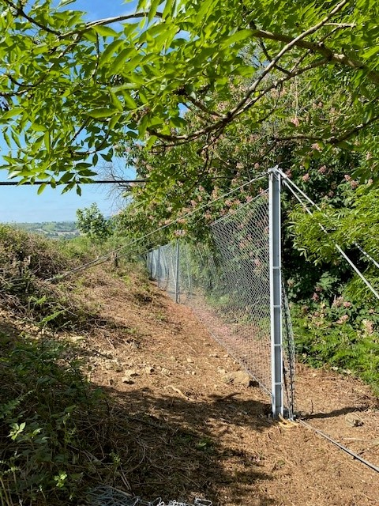
Work in Mines
- Roof/Wall Inspections.
- Roof Bolting.
- Installation of ladders, platform & walkways etc.
OUR SERVICES
Structural Repairs
- Brickwork & masonry repairs
- Tie bars & ground anchors
- Retaining walls
- Heritage Work - Re-construction & renovation of to stonework & stone arching.
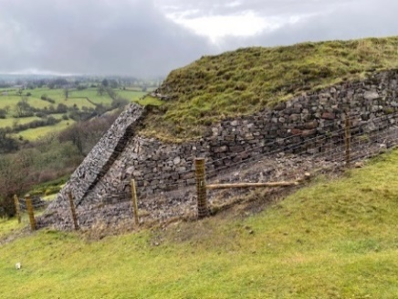
De-Vegetation
- Removal of light vegetation & scrub from rock faces & structures
- Large & difficult tree removal & felling
- Removal & treatment of invasive species (e.g. Knot Weed and Himalayan Balsam etc.)
- Herbicide treatment incl. eco plugging
Geotechnical Inspection & Ecological Surveys/Work Support
- Supporting, assisting & enabling geotechnical engineers/geologists to access slopes & faces.
- Supporting & assisting ecologists to access slopes & faces to undertake surveys, inspection & works

