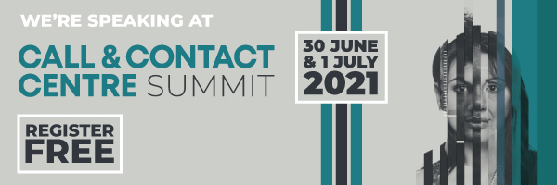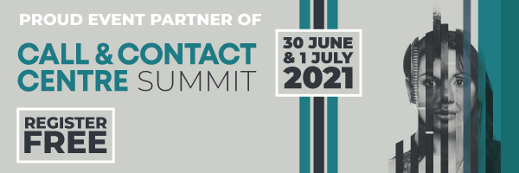

**Please note, this is only a guideline and should be adapted to suit your particular audience or business.**

**Call & Contact Centre 2021**

**…………………………………………………………………………………………………………...**

Hi **<<name>>,**

We’re extremely excited to announce that we are part of the Call & Contact Centre Summit 2021, on 30th June and 1st July 2021, and we’d really love for you to join us online!

The tools, techniques and systems revolutionising the world of customer engagement, experience, communication and connection will come to you from the comfort of your home, office or wherever you may be, with access through our online digital platform to:

* Watch insightful seminars from marketing experts
* Engage in live Q&A sessions
* Explore innovative products and solutions from leading vendors
* Network virtually with industry peers through video chat

**What's on**

Expert-led seminar sessions on:

The Future of Contact Centre

The Cloud Contact Centre

Virtual/Work From Anywhere Technologies

Customer Service / Customer Engagement

CX/UX Innovation

Customer Insights

Big Data / AI

Employee Engagement

**Live demos of the latest technology.**

**Industry leading companies equipped with the finest solutions, led products and services.**

This is a fantastic opportunity to discover all the technologies, strategies and advancements to help you excel in the customer engagement and experience world!

REGISTER FREE today!

**<<your sign off>>**