  - How improved vision is changing
lives in care homes

In care homes across the UK, the demand for eye care among the elderly is growing. This demographic, despite their clear and urgent need, has often remained overlooked.
However, we’re making it our mission to increase awareness of how good eyesight is crucial in protecting against common risks faced by the elderly, including falls, loneliness, and cognitive decline.
The statistics are telling: people aged over 65 are prone to experience one or more falls a year, with this likelihood jumping to 50% for those over 80.
These falls are not just distressing for the individuals and their families; they also bear a significant economic burden. The NHS spends over £2 billion annually on care and treatment related to falls – that's about £6 million each day.
In response to this increasing demand for eye care, we are expanding our team of dedicated care home optometrists to be able to better serve our care home partners. This expansion is part of our vision to ensure quicker access to quality eye care for our customers, particularly those in care homes.
We believe that by enhancing our services, we can play a pivotal role in reducing the incidence of falls among the elderly and contribute to their overall well-being and independence.
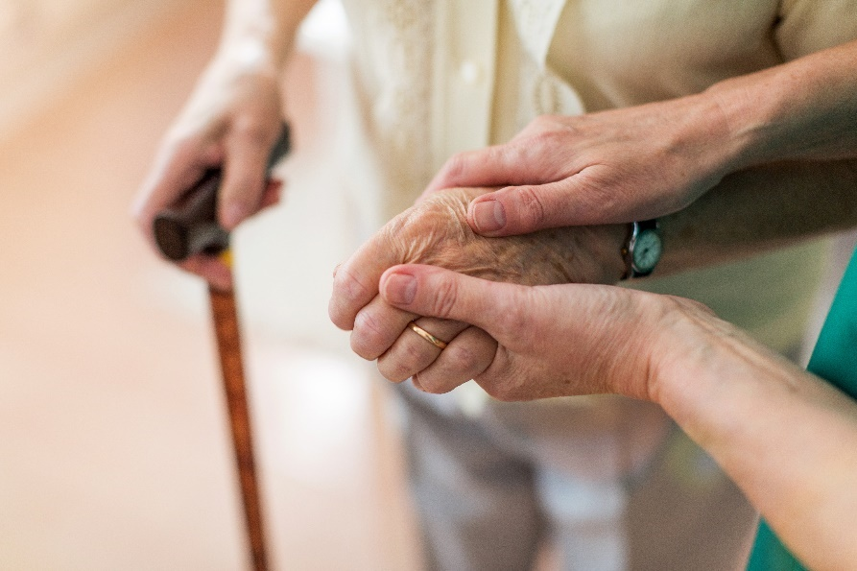
To further our ambitions and challenge common misconceptions about care homes, we've developed a series of enlightening videos that advocate for better eye care in these settings.
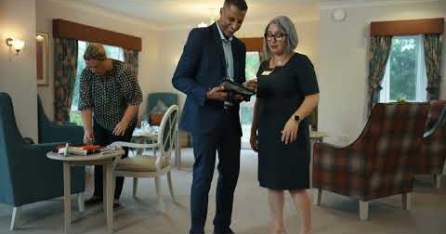

Every day we hear stories that show us the impact that our work has, not only on the patient themselves, but their families, and the wonderful carers that are with them around the clock.
One remarkable transformation is that of Jean, our patient, who progressed from being nearly completely blind and dependent on 24-hour one-to-one support, to regaining her independence, rediscovering the joy of reading her favourite books and actively socialising with fellow residents.
Read the full story here

Care home professionals interested in enhancing their residents' eye health can discover more about our services on the OutsideClinic website.
We're excited to form new partnerships at the upcoming UK Care Week's conference, where we'll showcase our dedication to this vital cause.
Join us in making a real difference!
End -

