Children’s Air Ambulance and Sustainability

As the wider public are making conscious decisions as consumers, more businesses are now focusing on their Corporate Social Responsibilities than ever before. The Air Ambulance Service, through their Reuse department, are actively partnering with businesses to provide a sustainable and cost-effective way to support a lifesaving charity, offering a solution to both their environmental and social responsibilities.
IT and Technology are ingrained in to even the simplest of organisations. With failures often having severe consequences, many businesses and institutions find themselves regularly updating their equipment but are aware and concerned about the environmental impact and GDPR restrictions of disposing of tech incorrectly. The IT Asset Reuse department can provide a free collection and data secure solution to this, giving organisations peace of mind.
Celebrating over 10 years since the first placement of a clothing bank The Air Ambulance Service reflect on the amazing, continued support and growth this department has seen, with now over a thousand clothing banks each funding a mission for every 15 times it’s full. Organisations with a car park and other outdoor spaces can consider supporting The Children’s Air Ambulance Service by hosting a clothing bank, the Reuse of clothing not only helps divert tonnes of textiles from landfill but also provides an incredible source of funding to support in the transfer of critically ill children and babies.

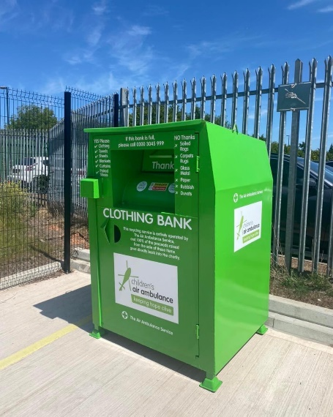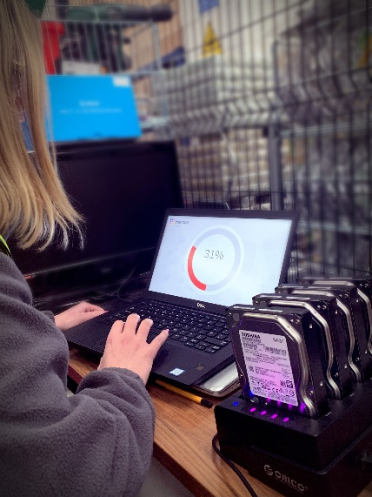
You can also support the Children’s Air Ambulance through Charity of the year partnerships, challenge events and fundraising. There are many ways we can engage and support you; whether you have a large head office or many locations across the country, we’re able to give you the help and support needed to make your fundraising efforts as fun and rewarding as possible.
Across the many divisions that make up our charity, including, Fundraising, Events, Reuse, Retail & Trading, we’ll work together to ensure our partnership is as varied and engaging as possible, and with our years of expertise in this area, we will be able to provide the advice, support, and collateral you’ll need.
Whether it is giving your time, Gifts In Kind or expertise you wish to support us with, we work to ensure the partnership is a joy for both parties. We’ll learn about your organisation, your staff and values to ensure we are both aligned towards achieving the best partnership possible.
For more information, please contact us on 0300 304 5999 or email reuse@theairambulanceservice.org.uk
https://theairambulanceservice.org.uk/

