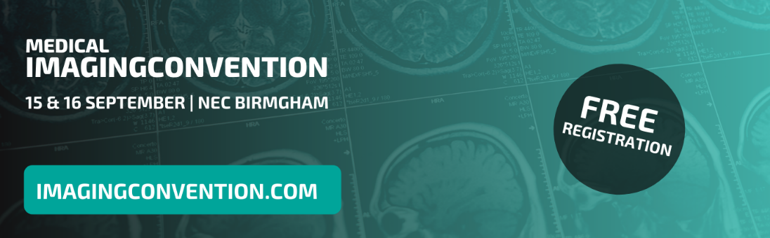

Medical Imaging Convention | 100 words
Please note, this is only a guideline and should be adapted to suit your audience or business.

15th & 16th September, NEC, Birmingham

Experience the future of imaging at the Medical Imaging Convention. This event provides the most up-to-date research, data and developments that will enable better patient outcomes, efficiency and cost effectiveness in UK medical imaging. The event focuses on six key areas: MRI, CT, X-ray, Ultrasound, Breast Screening and AI & Machine Learning.

Meet, learn from and interact with specialised exhibitors, leading speakers and fellow clinicians. This is your opportunity to understand how the latest equipment and technology can improve your service delivery and ultimately better patient outcomes!

Register for your free tickets at www.imagingconvention.com

