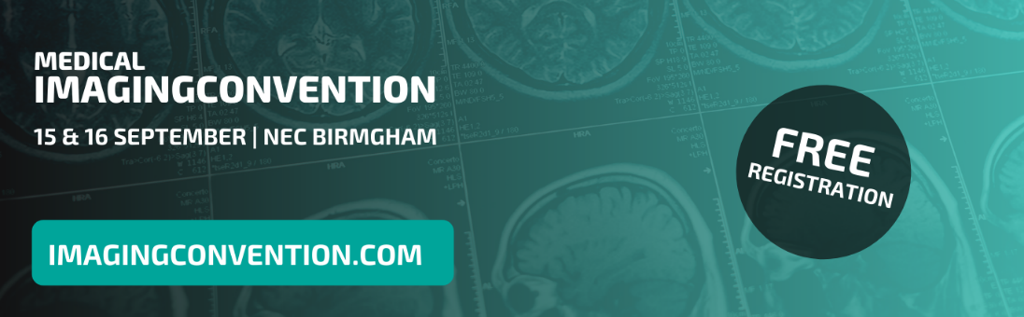

Medical Imaging Convention | 200 words
Please note, this is only a guideline and should be adapted to suit your audience or business.

15th & 16th September, NEC, Birmingham

Experience the future of imaging at the Medical Imaging Convention. This event provides the most up-to-date research, data and developments that will enable better patient outcomes, efficiency and cost effectiveness in UK medical imaging. The event focuses on six key areas: MRI, CT, X-ray, Ultrasound, Breast Screening and AI & Machine Learning.

Explore the exhibition and meet with some of the world’s leading technology, equipment and software manufacturers. Exhibitors such as headline sponsor Philips, will be running live demonstrations throughout the event, providing the perfect opportunity for you and your team to trial the emerging equipment and technology that can positively impact your service delivery.

A CPD accredited seminar programme will run alongside the exhibition, hosted by the leading clinicians and researchers in worldwide medical imaging. Focused on the key areas of the event the programme features sessions from the likes of Philips, Microsoft, HP, The Institute of Cancer Research, BNMS and many more!

After successfully implementing the digitisation process across all UK hospitals and NHS trusts for the last decade, the Commissioning and Routine Testing of Full Field Digital Mammography Systems dictates that all digital imaging technology used for breast screening is due for an update in 2020/2021. As part of the seminar programme, the National Breast Screening Programme will be running their own theatre featuring the most updated content, technology and research from the likes of Hologic, Siemens, GE Healthcare.

The AI & Machine Learning Convention also joins the Medical Imaging Convention as a zone of the event. Dedicated to exhibiting technology which is really just being introduced across hospital services, this is a truly pioneering event that will shape the future of healthcare. Fit with its very own exhibition and seminar programme featuring the likes of NHS England, Terarecon, The University of Edinburgh, World Health Organization, Sectra and Microsoft, this is not to be missed!

Register for your FREE tickets at www.imagingconvention.com

