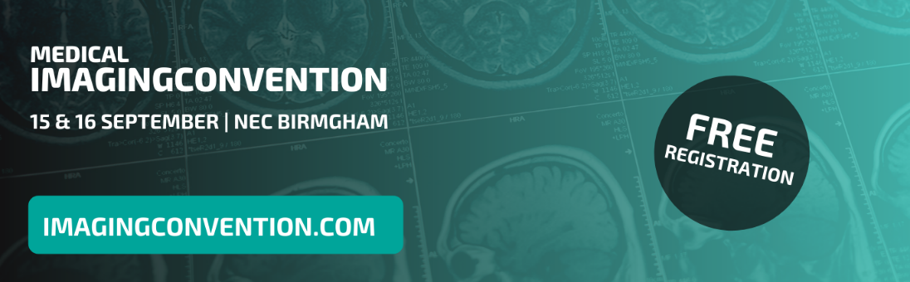
Exhibitor Invitation to Contacts – Medical Imaging Convention

Subject Line
Come and meet us at MIC! 🤝
Email Body
Hi (First Name),
We are delighted to announce that we will be exhibiting at the Medical Imaging Convention, on the 15th & 16th September 2021 at Birmingham’s NEC! Specialising in MRI, CT, X-ray, ultrasound and breast screening, this event provides the most up-to-date research, data and developments that will enable better patient outcomes, efficiency and cost effectiveness in UK medical imaging. See what’s on at www.imagingconvention.com

We’re exhibiting on stand (Your Stand Number) – come and say hello! We’ll be on-hand all day to show you how (Your Product/Service) can improve your service delivery, streamline your workload and ultimately better patient outcomes by (Your Product/Service Function).

Grab your free tickets at www.imagingconvention.com - we look forward to meeting you!

Don’t forget to link the website (in yellow) to your personalised tracked link!

