Bolt Burdon Kemp LLP and Cerebra: Empowering lives
Bolt Burdon Kemp, a leading law firm dedicated to representing individuals who have suffered serious injuries, is thrilled to be partnering with Cerebra, the charity that enhances the lives of children with neurological conditions, at Naidex 2024.
Bolt Burdon Kemp and Cerebra’s long-standing partnership stems from a shared commitment to improve lives through bespoke solutions, with Cerebra’s designs helping disabled children discover and engage with the world around them.
From lightweight carbon fibre crutches to its adaptive paddleboard, you can see for yourself some of the innovative custom-designed products Cerebra Innovation Centre has developed by coming to see us on stand G100.

About Bolt Burdon Kemp
Our mission at Bolt Burdon Kemp is to secure the compensation our clients need to rebuild their lives, even in the face of life-altering circumstances. We place our clients at the heart of everything we do, advocating for justice every step of the way.

Our client-centred approach
When our clients come to us, they’re often facing challenging times. Whether it’s a brain, spinal cord or other complex personal injury claim, medical negligence case, or military injury, we understand that everyone is unique and approach each situation with empathy and expertise. We’ve earned our reputation for excellence because we care about our clients and always aim to make their lives better. But we know from over 35 years’ experience that compensation is only part of the answer.
As soon as we’re instructed, we’ll put in place a support structure tailored to address the unique legal and administrative pressures facing our client and their family. Wherever possible, we’ll arrange physical rehabilitation packages (potentially even before the claim is made). We recognise the immense impact early intervention – such as educational support, professional care and specialist equipment – can have on an injured person’s quality of life in the longer term, so will get early and regular interim payments to put in place an individualised care and therapy package at the earliest possible opportunity.

The role of technology
In complex claims, technology plays a crucial role. From assistive devices to adaptive home modifications, we make certain our clients have access to the latest advances. Working with experts from multiple disciplines, we explore the full range of hardware and software that can make a real practical difference to our clients’ lives. We advocate for our clients, making sure that the cost of essential technology is factored into the claim so our clients receive the support they need to lead rich and fulfilling lives as independently as possible.

Driving innovation through collaboration
At Bolt Burdon Kemp, we’re passionate about making a difference. Our commitment extends beyond legal services; it’s about positively impacting lives. That’s why we’re proud to support Cerebra and to collaborate with them.
Cerebra’s multifaceted approach includes research, information dissemination, and direct ongoing support. Cerebra’s Innovation Centre’s small but dedicated team offers a bespoke product design service for families. They understand that off-the-shelf equipment often falls short in terms of aesthetics and functionality for children with specific needs. By creating custom solutions, Cerebra bridges the gap, ensuring that children have access to equipment that not only serves its purpose but also brings joy and dignity to their lives.
By collaborating with Cerebra, we gain insights, learn from their expertise, and contribute to meaningful change. Together with the Cerebra Innovation Centre, we foster creativity and champion inclusivity through our Prototype Projects and our Design the Change competitions.

Prototype projects
Our innovative prototype projects address specific challenges faced by children with neurological conditions. From designing custom communication devices to creating sensory-friendly environments, we’re committed to finding practical solutions. Our latest collaboration involved adapting an E-scooter for a client with cerebral palsy. Described by the family as “awesome”, it offers a customised design for safety, comfort and adventure.

Design competitions
Creativity thrives when we collaborate with Cerebra. Our annual Design the Change competition encourages fresh ideas. The competition, now in its third year, is intended to raise awareness of the day-to-day challenges facing people with spinal cord injuries and how innovative designs can make a real difference. The competition invites UK-based university students to design a product aimed at improving the lives of people with a spinal cord injury. Whether it’s a wheelchair-friendly playground or an inclusive learning space, these competitions inspire us. We believe that design can transform lives, and our work with Cerebra Innovation Centre, which supports the competition and is on the panel of judges, exemplifies this belief.
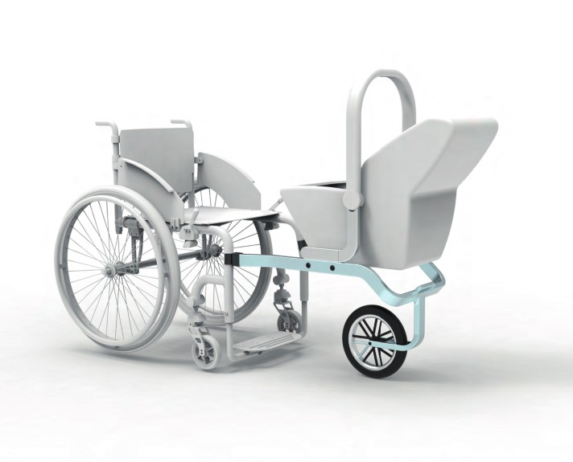

Why are we partnering with Cerebra?
Bolt Burdon Kemp and Cerebra share a commitment to social impact, community engagement, and making a positive difference. From designing beautiful yet functional products to supporting families, Cerebra aligns perfectly with our commitment to improving lives. Together, we amplify our impact.
So, the next time you see the Bolt Burdon Kemp logo, know that it stands for more than legal services. It symbolises a commitment to justice, compassion, and partnership – especially with organisations like Cerebra.

Contact Us
Cheryl Abrahams - Partner – Part of the Child Brain Injury Team
020 7288 4854
07912 248 695
cherylabrahams@bbkllp.co.uk

