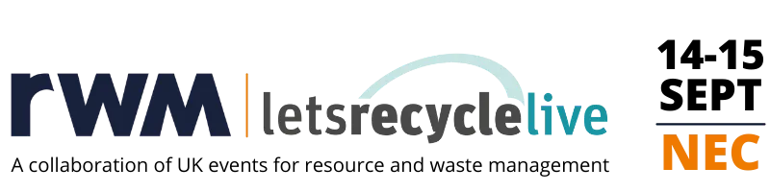
PRESS RELEASE
<<YOUR COMPANY>> TO EXHIBIT AT RWM & LETSRECYCLE LIVE

<<your company>> are excited to announce that they will exhibiting at RWM & Letsrecycle Live 2022.

<<insert information about any products/services that you will be bringing or launching, or what will be on offer at your stand, as well as your stand number>>

Taking place on 14-15 September 2022, at the NEC, in Birmingham, the RWM & Letsrecycle Live event is set to be bigger and better than ever; serving as the UK’s largest event for the recycling, resource and wider environmental services sector.

Speaking ahead of the event <<insert name and your company name>> said, <<insert quote about what you’re exhibiting and why>>.

The event is set to welcome 12,000+ visitors, more than 800 exhibitors and 200 speakers across indoor and outdoor exhibition spaces, 10 conference theatres, live demonstration areas, and much more.

RWM & Letsrecycle Live is free to attend, and you can register for your ticket here: ADD YOUR COMPANY’S UNIQUE REGISTRATION LINK. We look forward to welcoming you to what is sure to be the most comprehensive, thought-provoking, and valuable event in the recycling, resource and waste management diary.

To find out more about RWM & Letsrecycle Live, visit www.rwmexhibition.com where you can subscribe to RWM Insights for more industry and event updates.

ENDS

