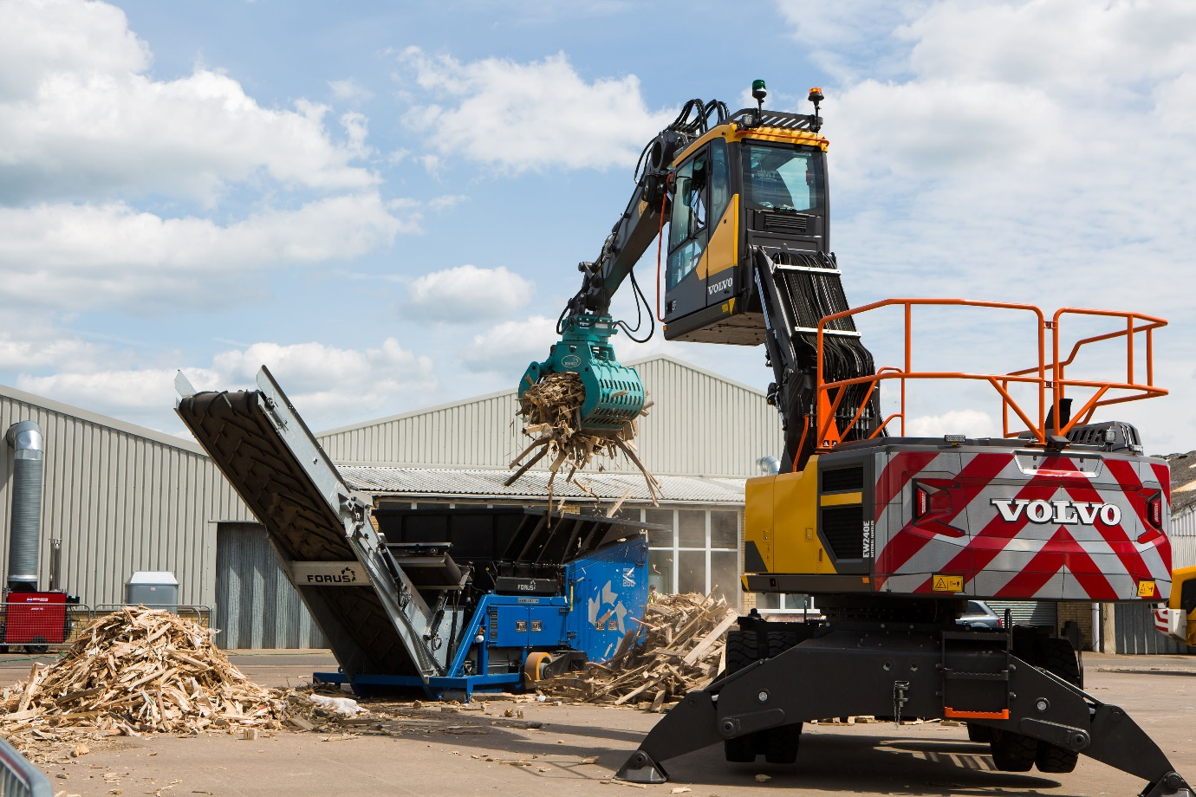

<<YOUR COMPANY>> TO EXHIBIT AT RWM & LETSRECYCLE LIVE
A collaboration between the two leading UK events, RWM & Letsrecycle Live combine to form the UK’s largest event for the recycling, resource and wider environmental services sector. The best of both events, the 2022 event features 12,000+ attendees, 300+ speakers across 9 conference theatres, 550+ exhibitors, live material processing, 50+ vehicle demonstrations and exclusive free to attend networking events including the Local Authority Lounge, Women in Sustainability, private meetings, the Careers Corner, the Innovation Awards and much more.

<<your company>> look forward to being part of a bigger, better, and revitalised event for the industry. Come and visit us on stand <<insert your stand number, and information about any products/services that you will be bringing or launching, or what will be on offer at your stand>>.
To register for your free ticket or for more information please visit: ADD YOUR COMPANY’S UNIQUE REGISTRATION LINK
Date: 14-15 September 2022
Venue: The NEC, Birmingham
Halls: 17-20
Opening Times: 9.30 - 5pm

