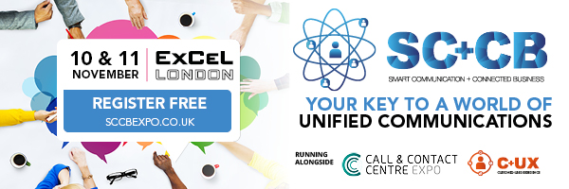

Please note, this is only a guideline and should be adapted to suit your particular audience or business.

Smart Communication + Connected Business Expo 2020

The tools, techniques and systems revolutionising the world of business and unified communications will be taking the UK by storm on the 10th & 11th November 2020, when the Smart Communication + Connected Business Expo makes its long-anticipated debut at London’s ExCeL!

Your free ticket for the Smart Communication + Connected Business Expo will also give you unprecedented access to the Call & Contact Centre Expo and the Customer & User Experience Expo, the combination of which promises to bring you the greatest customer engagement event in all of Europe! With a combined line of cutting-edge and industry leading exhibitors, and expert keynotes and seminars, this is going to be a show like no other!

Register FREE today to catch us at the show.

TRACKED CODE TO WEBSITE: Please embed your unique tracking code behind highlighted text.

