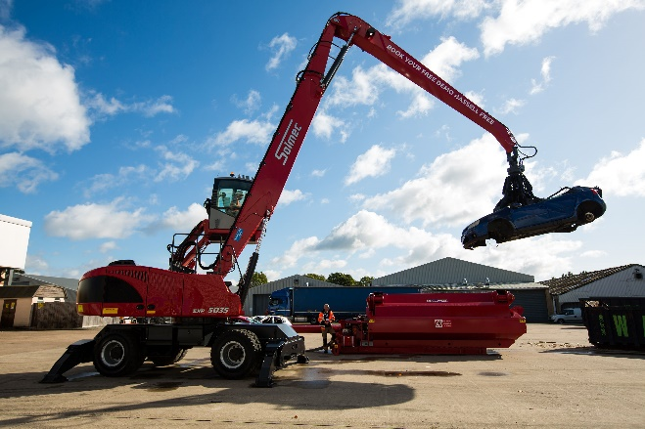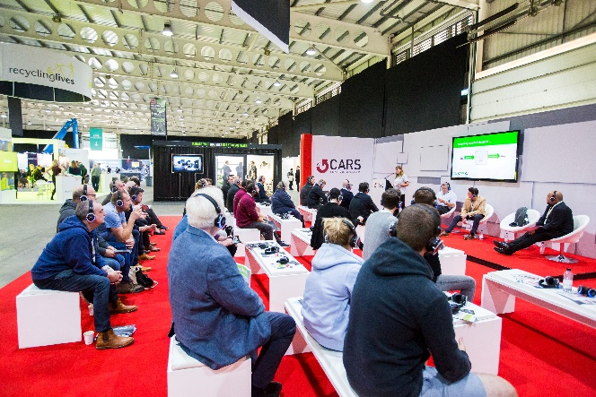

<<insert your company>> TO EXHIBIT AT THE COMPLETE AUTO RECYCLING EVENT AND METALS RECYCLING SHOW 2023

CARS & MRE returns to Stoneleigh Park, Coventry, UK for 2023 – delivering Europe’s leading event for the vehicle recycling, dismantling, and metals recycling sectors.

2023 expects to see 1700+ professionals came together for two action packed days at the biennial event to hear the latest and leading live updates in the sector from 40+ speakers, see live material processing demonstrations, network with 90+ exhibitors and join in on a range of free to attend networking events including: Meet the Buyer, Association AGMs, Skills Lab training sessions, the CARS & MRE charity dinner, live competitions, off site tours and much more!
<<your company>> look forward to being part of an enhanced event for the industry. Come and visit us on stand <<insert your stand number, and information about any products/services that you will be bringing or launching, or what will be on offer at your stand>>. To register for your free ticket or for more information please visit: << insert your personal tracking link here – located in ezone>>

Date: 24-25 May 2023
Venue: Stoneleigh Park, Coventry
Opening Times: 09.30am - 17.00pm
________________

