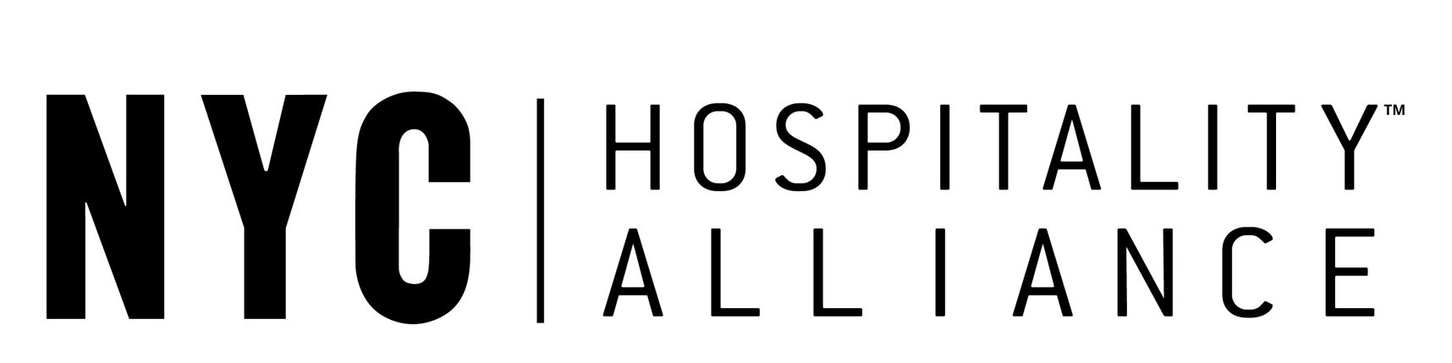

SFOR IMMEDIATE RELEASE:
For more information, contact:
Amy Riemer, Media Relations
978-475-4441 (office) 978-502-4895 (cell)
amy@riemercommunications.com

NEW YORK CITY HOSPITALITY ALLIANCE BECOMES AN ASSOCIATION PARTNER OF THE INTERNATIONAL RESTAURANT & FOODSERVICE SHOW OF NEW YORK
Trade Show and Conference Scheduled for March 3-5, 2024, at Javits Center in New York City

New York, NY, December 11, 2023 – The International Restaurant & Foodservice Show of New York the premier event for New York’s hospitality industry, owned by Restaurant Events, LCC has announced that the NYC Hospitality Alliance (The Alliance) has signed on to be an Association Partner for the trade show and conference taking place Sunday, March 3 through Tuesday, March 5, 2024 at the Javits Center in New York City. The Alliance is the leading voice of New York City’s restaurant and nightlife industry in the five boroughs of New York City.

“One of the pillars we outlined when we acquired the International Restaurant Show was to ensure we evolved and enhanced it to best serve the market. That’s why I am so thrilled to announce this partnership with the NYC Hospitality Alliance and look forward to working with them to bring the solutions and ideas to the specific challenges faced by NYC area operators,” said Glenn Celentano, CEO & Partner, Restaurant Events, producers of the trade show and conference. “We welcome their members, who represent the restaurant and foodservice community from the five boroughs to the show. Restaurant, foodservice, nightlife and specialty coffee professionals will find a convenient and efficient way to access industry experts addressing key issues in three days of education sessions, shop and sample a full range of products from leading vendors and be inspired and entertained from several exciting special events and competitions.”

“Many of our members have attended the International Restaurant & Foodservice Show of New York and we are thrilled to join this leading event as an Association Partner, while bringing in a whole new group of hospitality professionals to experience the show for the first time,” said Andrew Rigie, Executive Director, NYC Hospitality Alliance. “As an Association Partner, during the event, we will be hosting our annual State of The Industry Conference for all attendees to hear from leading industry experts and we will also hold our quarterly board meeting, giving our stellar board of directors the opportunity to discover the best in the restaurant and food service industry – from the newest food trends to the best in technology.”

The New York City Hospitality Alliance (The Alliance) is a not-for-profit association founded in 2012 to represent and serve restaurant and nightlife establishments throughout the five boroughs. Home to more than 20,000 eating and drinking establishments, employing more than a quarter of a million people, the industry is vital to the economic foundation and social fabric of New York City. The Alliance bridges the gap between the hospitality industry, government, and the press. They advocate for a fair and equitable regulatory environment that removes barriers to entrepreneurship and job creation and seek to reduce unnecessary regulatory burdens, streamline the permit and licensing process, cut the red tape, and represent the industry’s perspective on proposed laws, regulations, trends, and other matters impacting restaurant and nightlife establishments.

The International Restaurant & Foodservice Show of New York, sponsored by the New York State Restaurant Association (www.nysra.org), provides thousands of industry professionals with access to a renowned education program, special events, and hundreds of leading vendors and purveyors dedicated to serving the restaurant & foodservice community. The show will be co-located with Coffee Fest giving all attendees access to both events in the same exhibit hall. The two events will offer hundreds of exhibiting companies and over 80 hours of education programs, dozens of special events including culinary competitions, demonstrations, and several networking opportunities.

To register for the International Restaurant & Foodservice Show of New York, click here. For exhibitor information contact Paul Pedrow at (484) 823-9608 or paul@therestaurantevents.com. The International Restaurant & Foodservice Show of New York, to be held March 3-5, 2024, at the Javits Center in New York City is sponsored by the New York State Restaurant Association, (NYSRA). The trade show and conference is owned by Restaurant Events, LLC which also produces the Florida Restaurant & Lodging Show and Pizza Tomorrow Summit, to be held November 6-7, 2024 at the Orange County Convention Center in Orlando, FL and the 2024 Western Foodservice & Hospitality Expo to be held August 25-27 at the Los Angeles Convention Center.

# # #

