About EAGE
The European Association of Geoscientists and Engineers (EAGE) is a leading global professional association for geoscience and engineering professionals, bringing together academia, industry, and research to advance the understanding of the Earth’s subsurface. Headquartered in the Netherlands, with regional offices in Dubai, Kuala Lumpur, and Bogotá, EAGE supports a truly international community spanning more than 100 countries.
EAGE promotes a multidisciplinary approach across geoscience, engineering, and energy related fields, fostering technical excellence, innovation, and knowledge exchange. Its members’ expertise covers the sustainable development of natural resources, including oil and gas, geothermal energy, minerals, groundwater, infrastructure integrity, environmental protection, and geohazard mitigation.
As the energy landscape evolves, EAGE and its community play an active role in the energy transition, supporting technologies such as carbon capture and storage, geothermal energy, hydrogen, and offshore wind, where subsurface knowledge is critical. The Association also embraces digitalization, artificial intelligence, and machine learning as key drivers of future geoscience applications.
EAGE delivers value through a global portfolio of conferences and exhibitions, education and training programmes, publications, special interest communities, and an extensive network of local chapters. Through close collaboration with universities, industry, and public institutions, EAGE advances geoscience knowledge and its positive impact on society worldwide.

About EAGE President
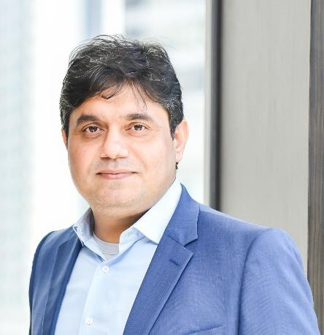
Dr. Sanjeev Rajput is the EAGE President for the 2025–2026 term and Custodian and Head of Reservoir Geoscience at PETRONAS Upstream Exploration and Development.
He holds a Senior Executive MBA from Melbourne Business School, a PhD in Natural Sciences (Applied Geophysics) from Kurukshetra University, India, and a Postdoctoral Fellowship from The University of Texas at Austin, USA. His academic foundation is complemented by certifications in Project Management from Stanford University, Lean Six Sigma Green Belt, and Sustainability from the University of Cambridge, reflecting his commitment to lifelong learning and leadership excellence.
A strategic visionary in the energy sector, Dr. Rajput is renowned for pioneering the first Digital Oil Field concept and advancing Carbon Capture and Storage, consistently integrating cutting-edge technologies with strategic business goals. An acclaimed author and mentor, he has published over 100 peer-reviewed papers and co-authored three textbooks on geology, geophysics, energy transition, and Front-End Loading. Beyond his technical expertise, he is deeply committed to sustainability, responsible energy development, and corporate stewardship.

