About SEG
The Society of Exploration Geophysicists (SEG) is a global not-for-profit organization with a mission of connecting the world of applied geophysics.
Founded in 1930, SEG provides information, tools, and resources vital to advancing the science of exploration geophysics, fostering common scientific interests, supporting humanitarian efforts, and accelerating geophysical innovation.
Inspiring the geophysicists of today and tomorrow, SEG's long-standing tradition of excellence in education, professional development, new business generation, and engagement cultivates a unique community platform that encourages collaboration and thought leadership for the advancement of geophysical science around the world.
Headquartered in Houston, Texas, with regional offices in Dubai (UAE), Beijing (China), Kuala Lumpur (Malaysia), and Tulsa, Oklahoma, and hubs in Brazil and India, SEG is a global society dedicated to advancing the present and future of applied geophysics. https://seg.org/

About SEG President
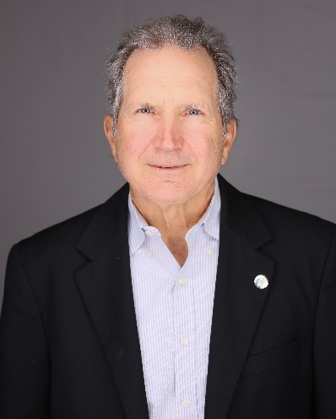
Joseph Reilly is 2025-2026 President of the Society of Exploration Geophysicists (SEG). He started his career working on government contracts related to geothermal energy and nuclear waste disposal, then he moved to the private energy industry. He has over 40 years of industry experience in addressing geoscience challenges throughout the world. He has held both technical and management positions across Exploration, Development, Production and Research, retiring as ExxonMobil Chief Research Geoscientist.
He is currently serving as an advisor to the state geologic survey of Virginia in field mapping and integration of geophysical and radiometric data over metamorphic terrain. He has authored/coauthored hundreds of papers and presentations on geophysical applications.
He holds a BSc in Geology from the University of Rochester and an MSc in Geology/Geophysics from Virginia Tech. He is a long-time member of SEG, GSH, EAGE, and AAPG, and is a licensed Geophysicist in the state of Texas.

