About SPE
The Society of Petroleum Engineers (SPE) is a not-for-profit professional association with 132,000 members in 146 countries engaged in the exploration and production of oil and gas and related energy resources.
SPE delivers solutions and empowers people to drive the energy industry forward. Members gain access to premier programs, content, and events designed to accelerate professional growth and career development, while fostering a strong network and sense of community. SPE maintains offices in Calgary, Dallas, Dubai, Houston and Kuala Lumpur.

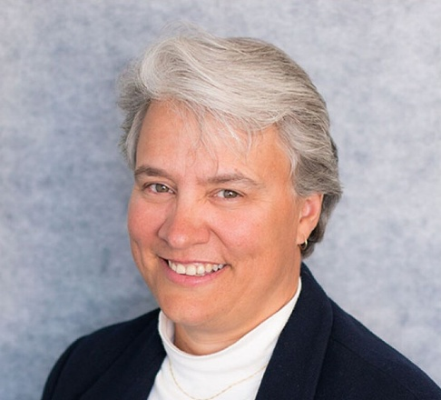
About SPE President
Jennifer L. Miskimins is a professor and the department head of the petroleum engineering department at the Colorado School of Mines (Mines), where she holds the F.H. Mick Merelli/Coterra Energy Distinguished Department Head Chair.
She has over 30 years of experience in the petroleum industry, starting with Marathon Oil Company as a production engineer. Miskimins began teaching at Mines in 2002 and has held various appointments since then. From 2013–2015, she held a part-time appointment at Mines while working at Barree & Associates. In 2016, she returned full-time to the university.
Miskimins served as the first Completions Technical Director on the SPE International Board of Directors. She was an SPE Distinguished Lecturer in 2010–2011 and 2013–2014. She was awarded the 2014 SPE Completions Optimization and Technology Award, and in 2022, she received the SPE Distinguished Achievement Award for Petroleum Engineering Faculty.
Miskimins has served on a variety of conference organizing committees, including chairing the 2023 and 2024 SPE Hydraulic Fracturing Conference and Exhibition, and as a technical editor for SPE journals, including serving as the executive editor of Production & Operations for 3 years. She was the editor in chief for the 2019 SPE Monograph update “Hydraulic Fracturing: Fundamentals and Advancements.” Miskimins has served on the AIME Board of Trustees since 2018 as an SPE trustee and was the 2022 AIME president.
Miskimins holds a BS from the Montana College of Mineral Science and Technology and MS and PhD degrees from the Colorado School of Mines, all in petroleum engineering.

