Booth Space Application Instructions

- Please login to the Exhibitor Hub to access the Exhibit Space Contract.
Note: Only primary, secondary and invoice contact will be able to set up their login credentials. Please ensure the email address you are using to login is associated with the account. If you are unsure, please contact spe.events@spe.org.

If you haven’t set up your Exhibitor Hub login yet, please visit the Exhibitor Academy, where you’ll find step-by-step instructions and a helpful walkthrough video.

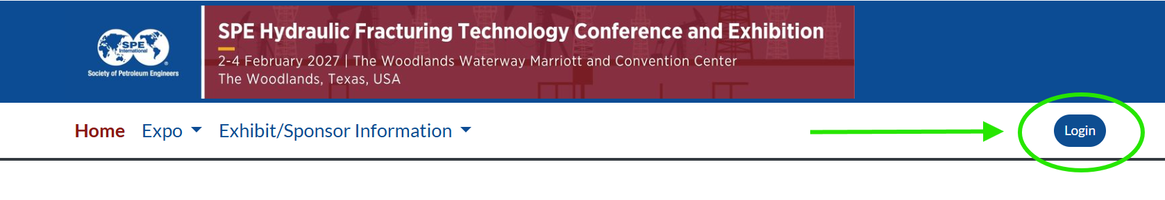

- Once logged in, hover over “Exhibit/Sponsor Information” and select “Exhibitor Hub.”
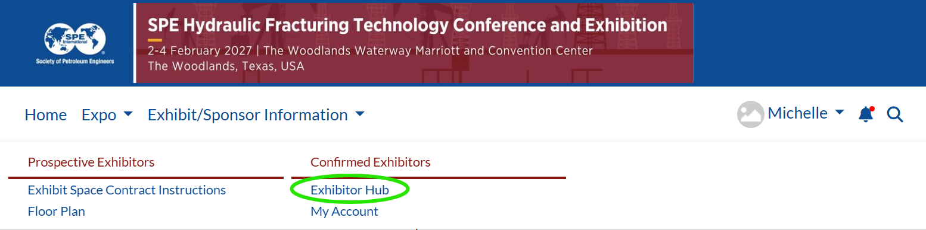

- Click the blue button under ‘Exhibit Space Agreement’
