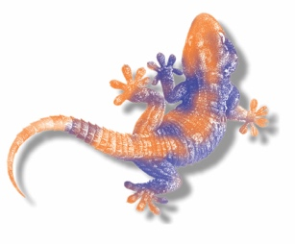 |  | Price list
Agama Creative |  | 2022
Photo Style Description Trade Price RRP

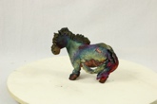 Short leg standing pony (+/- 10cm) £30 £60
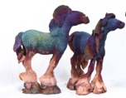 Long leg standing pony (+/- 19cm) £32 £65

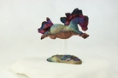 Jumping pony (+/- 19cm) £35 £70

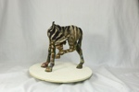 Medium standing pony/zebra (+/- 30cm) £175 £350

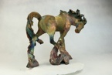 Large Standing Shires. (+/- 45cm) £300 £600

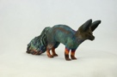 Small Foxes (+/- 12cm) £30 £60

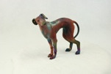 Small standing Greyhounds (+/- 16cm) £75 £150

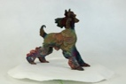 Small standing Afghans/Salukis (+/- 18cm) £80 £160

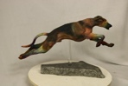 Small flying dogs (+/- 25cm) £90 £180

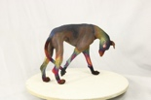 Large standing Sighthounds (+/- 25cm) £115 £230

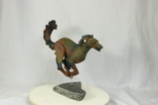 Large Flying Sighthounds (+/- 30cm) £135 £270

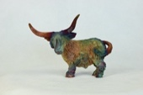 Little Highland cow (+/- 13cm) £32 £65

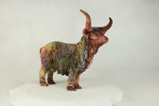 Medium Highland cow (+/- 23cm) £130 £260

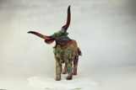 Large Highland cow (+/- 31cm) £200 £400

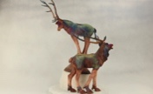 Medium Red Deer (+/- 40cm) £235 £470

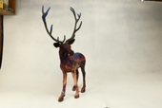 Large Red Deer (+/- 50cm) £335 £670

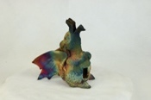 Little incense Burner Dragons (+/- 18cm) £32 £65

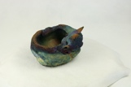 Dragon Bowls (+/- 9 x18x15 cm) £25 £50

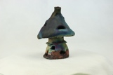 Fairy house Tea-light (+/- 16cm) £25 £50

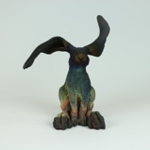 The Obligatory Hare! (+/- 16cm) £75 £150

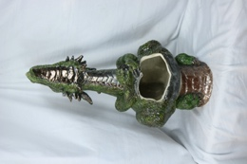 Large Dragon Chimineas (+/- 100cm) £300 £600

All my sculptures are one off pieces and best if viewed on the website before ordering. If ordering smaller items in bulk they will all be different, both in pose and colour.

Prices include delivery to mainland UK.

Our minimum trade order is £300.

Agama Creative
Pygmalion,
Crecas Lane, Carmel
Flintshire, CH8 8NN
Tel: 07503018293
Email: agama.creative@yahoo.co.uk
www.agamacreative.co.uk

