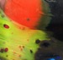

LEONA STEWART GLASS
Spring 2023

CODE Product Title Description Unit Cost
BIRDS – Standing & Hanging
CH1 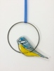 Blue Tit Circle Hanging £12
CH2 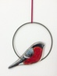 Bullfinch Circle Hanging £12
CH3 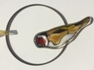 Goldfinch Circle Hanging £12
CH4 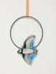 Flying Puffin Circle Hanging £12
CH5 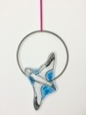 Diving Gannet Circle Hanging £12
CH8 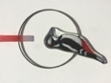 Woodpecker Circle Hanging £12
CH10 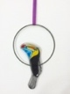 Tucan Circle Hanging £12
CH11 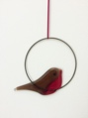 Robin Circle Hanging £10
CH12 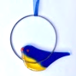 Abstract Bluetit Circle Hanging £10

CODE Product Title Description Unit Cost
BIRDS
SB1 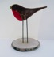 Standing Robin £12
SB1-1 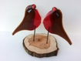 Robin LoveBirds £14
SB2 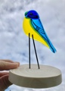 Standing Bluetit £12
SB2-1 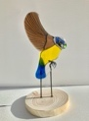 Flying Bluetit £14
SB3 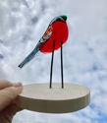 Standing Bullfinch £12
SB4 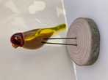 Standing Goldfinch £12
SB14-1 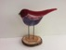 Standing Purple Bird £12
SB14-2 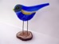 Standing Blue Bird £12
SB14-3 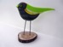 Standing Green Bird £12
SB15 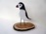 Standing Puffin £12
SB15-2 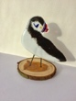 Puffin £12
SB15-3 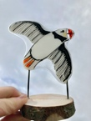 Flying Puffin £14
SB15-4 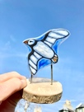 Flying Puffin 2 £12
SB16 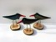 Standing Oyster Catcher £12
SB16-1 3 Oyster Catchers £33
SB16-2 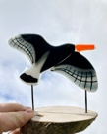 Flying Oyster Catcher £14
CODE Product Title Description Unit Cost

SB17 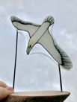 Diving Gannet £14
SB19 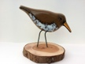 Sandpiper £12
SB20 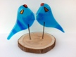 LoveBirds Standing – Red, Blue or Yellow £14
SB22 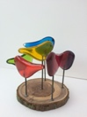 Rainbow Birds £14
SB22-1 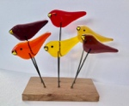 Bird Arch Reds £14
SB22-2 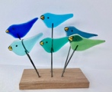 Bird Arch Blues £14
SB23 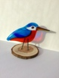 Kingfisher £12
SB24 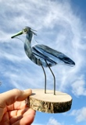 Heron £14
SB25 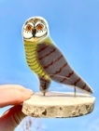 Owl £14
SB27 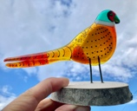 Pheasant £14
SB28 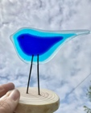 3 in 1 Blue Bird £12
SB29 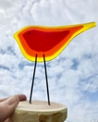 3 in 1 Red Bird £12

CODE Product Title Description Unit Cost

H2 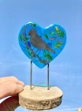 Blackbird Heart – Blue £12
H3 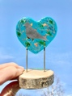 BlackBird Heart - Green £12
H4 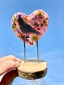 BlackBird Heart – Pink £12
H7 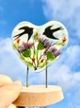 Swift & Thistles Heart £14
H8 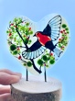 Flying Robin Heart £14
H9 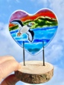 Scottish Seascape Heart £14
FISH/THE SEA
HF3 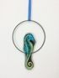 Sea Horse Circle Hanging £12
HF4 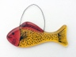 Little Gold Fish £10
HF4-1 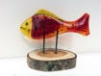 Standing Gold Fish £12
HF5 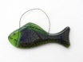 Little Green Fish £10
HF5-1 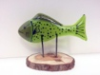 Standing Little Green Fish £12
HF6 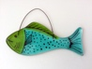 Little Blue Fish £10
HF6-1 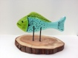 Standing Little Blue Fish £12
SF2 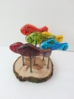 Rainbow Fish £14
SF3 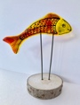 Jumping Fish £12
SF4 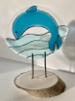 Jumping Dolphin £14
SF5 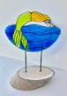 Jumping Mermaid £14
CODE Product Title Description Unit Cost
Y1 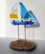 Standing Fused Glass Yacht £12
FB1 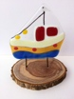 Fishing Boat 1 £12
FLOWERS/BUTTERFLIES/OTHER PRODUCTS
WB1 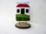 Standing Fused Glass Wee Bothy £14
WB1-2 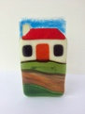 Wee Bothy T-Light Holder £14
B1-1 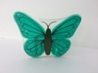 Painted Teal Butterfly T-Light Holder £12
B1-2 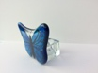 Painted Blue Butterfly T-Light Holder £12
B1-3 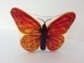 Painted Red Butterfly T-Light Holder £12
B2 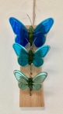 3 Butterflies Hanging Blue £30
B2 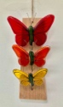 3 Butterflies Hanging Reds £30
DF1 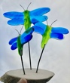 3 Dragonflies Blue £30
DF2 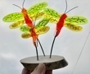 3 Dragonflies Green/Yellow £30
FL1 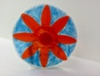 Orange Flower T-Light Holder £12
FL1-2 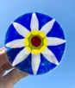 White Flower T-Light Holder £12
FL1-3 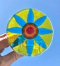 Turquoise Flower T-Light Holder £12
FL1-4 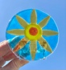 Amber Flower T-Light Holder £12
FL2 Whippet & Blackbird T-Light Holder £14
FL2-1 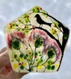 Blackbird & Thistle T-Light Holder £14

CODE Product Title Description Unit Cost

FL3 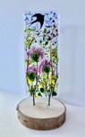 Swift & Thistle Standing £14
FL6 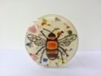 Bee T-Light Holder £12
FL7 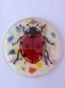 Ladybird T-Light Holder £12
XMAS
XM1 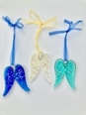 Glitter Angel Wings £8
XM7 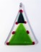 Xmas Tree 2 £10
XM7-1 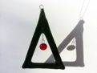 Green Xmas Tree/Red Dot £10
XM10 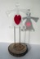 Standing Red Heart Angel – green, blue, teal, white £12
XM13 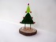 Standing Xmas Tree £12
XM13-1 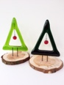 Standing Xmas Tree/Red Dot £12
XM22 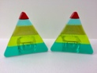 Xmas Triangle T-Light Holder (Each) £12
XM24 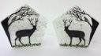 Stag & Bird T-Light Holder (Left or Right Facing) £14
XM29 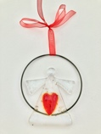 Angel Heart Circle Hanging – Red, Blue, Green £14

CODE Product Title Description Unit Cost

GH1 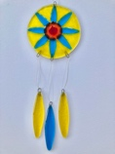 Garden Hanging – Turquoise Flower £16
GH2 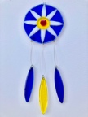 Garden Hanging – White Flower £16
GH3 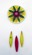 Garden Hanging – Green & Yellow Flower £16
GH4 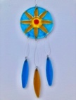 Garden Hanging – Amber Flower £16
GH5 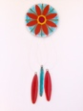 Garden Hanging – Blue & Orange Flower £16
GH6 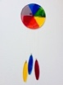 Garden Hanging – Rainbow £16
GH7 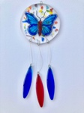 Garden Hanging – Colourful Painted Butterfly £16
GH12 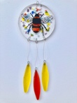 Garden Hanging – Painted Bumble Bee £16

MOBILES
MOB1 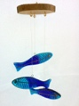 Blue Fish Mobile £17
MOB2 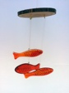 Red/Yellow Streaky Fish Mobile £17
MOB3 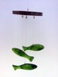 Green Fish Mobile £17
MOB4 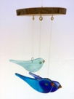 Blue Birds Mobile £17
MOB6 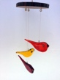 Coloured Birds Mobiles – Autumn £17
MOB7 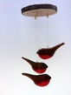 Robins Mobile £17

CODE Product Title Description Unit Cost
DICHROIC JEWELLERY
LS1 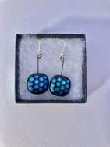 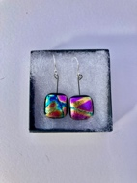 Medium Square Hanging Earrings £10
LS2 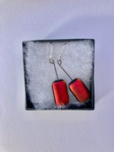 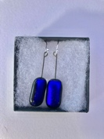 Rectangle Hanging Earrings £10
LS3 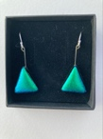 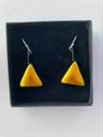 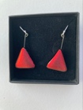Triangle Hanging Earrings £12
LS4 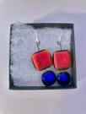 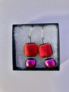 2 Drop Hanging Earrings £12
LS5 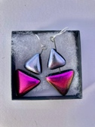 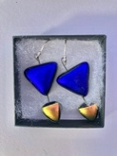 2 Drop Triangle Earrings £12
LS6 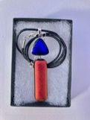 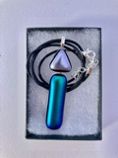 2 Drop Pendant £10
LS6-1 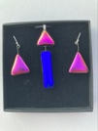 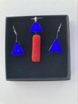 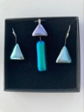 2 Drop Pendant Set £20
LS7 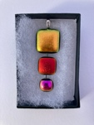 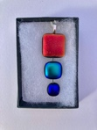 3 Drop Pendant £12
LS8 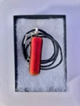 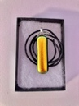 Medium Rectangle Pendant £8
LS8-1 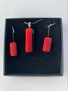 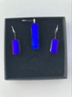 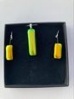 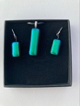 Rectangle Pendant Set £16
LS9 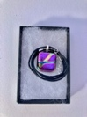 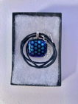 Square Pendant £9

CODE Product Title Description Unit Cost

LS9-1 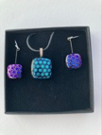 Square Pendant Set £18
LS10 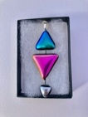 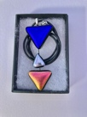 3 Drop Triangle Pendant £12
LS11 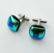 Cufflinks £14
LS12 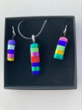 Stripey Pendant Set £20
LS13 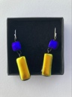 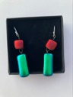 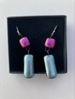 2 Tone hanging Earrings £14

All products are available in various colours. Earring hooks & backs are all silver. Pendants can come on either a black cord or an 18” chain. Jewellery comes in small black jewellery boxes.
TERMS
Minimum order for free delivery is £350. From placing order, delivery time is around 3-4 weeks (around 2 weeks longer for bespoke orders). New customers will pay for the first order prior to delivery, thereafter payment is due within 30 days.
Leona Stewart Glass, 10 Carrick Road, AYR, KA7 2RB Tel: 07886761598
Email: enquiries@leonastewartleadedglass.co.uk
www.leonastewartglass.co.uk

