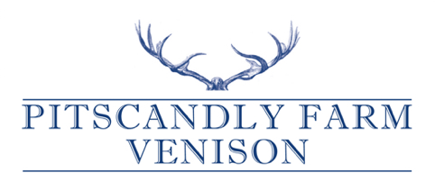

We are a beautiful farm based in rural Angus. Our herd was established in the late eighties and have roamed Pitscandly Hill ever since.

We specialise in providing traditionally reared, healthy, low fat Venison and have found demand rocketing year on year due to its natural qualities and wonderful taste.

As consumers become more concerned with where their food comes from, our customers love the field to fork transparency that we offer.

We sell whole beasts to the trade, butchered and packed, ready for cooking at a great price.

We hope your customers enjoy our Venison and we have a new recipe book ***“The Venison Kitchen”*** by Anona Gow which you may wish to sell too.

If you want any more information please do get in touch!

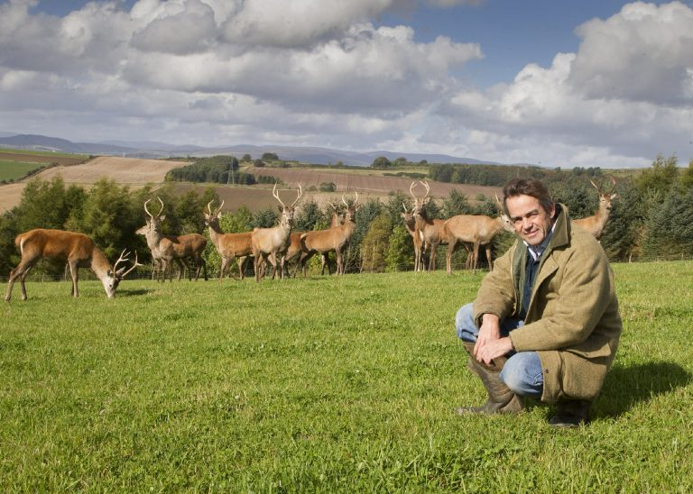

Jeremy Gow Pitscandly Farm, Forfar, Angus DD8 3NZ 07711 416 786

[www.pitscandlyfarm.co.uk](http://www.pitscandlyfarm.co.uk) [jeremy@knowyourantiques.com](mailto:jeremy@knowyourantiques.com)