Company Name
Contact Name
Contact Number
Stand Number
Event: International Robotics Conference 2023 (ICRA)
Date: Sunday 28th May to Friday 2nd June

Excel London
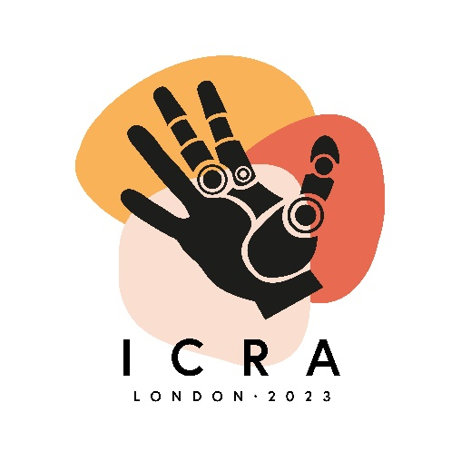
Capital Hall
Royal Victoria Dock
1 Western Gateway
London E16 1XL

